1. **Login Page**

<http://blogshub.co.in/sms/login>

**Enter User detail “Username” and “Password”**

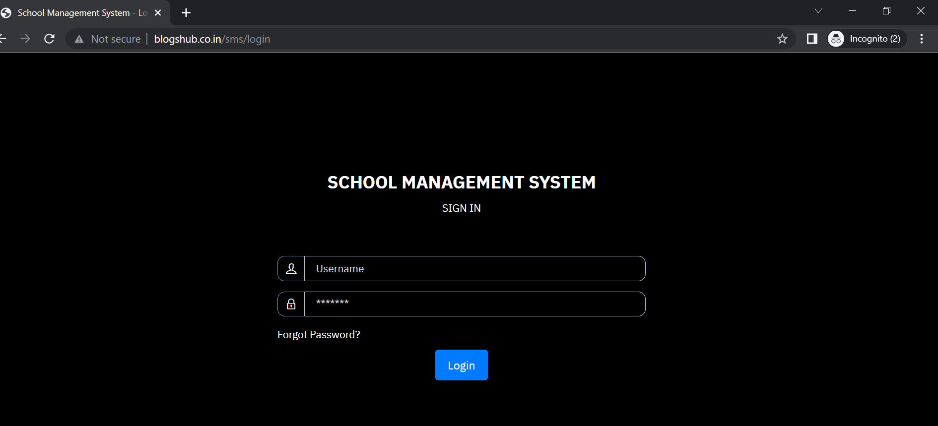

1. **Dashboard**

**In admin dashboard you can do all activity Like (Add , Edit and Delete)**

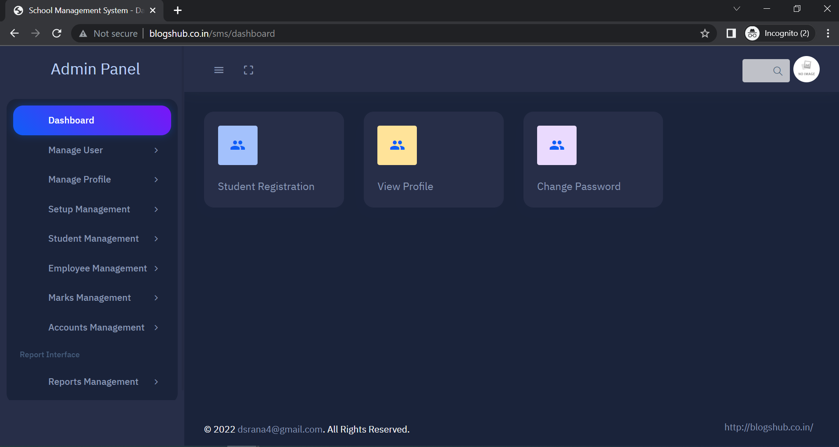

1. **Click on “Manage User” tab for expand it and then select “View User” to view all register users**

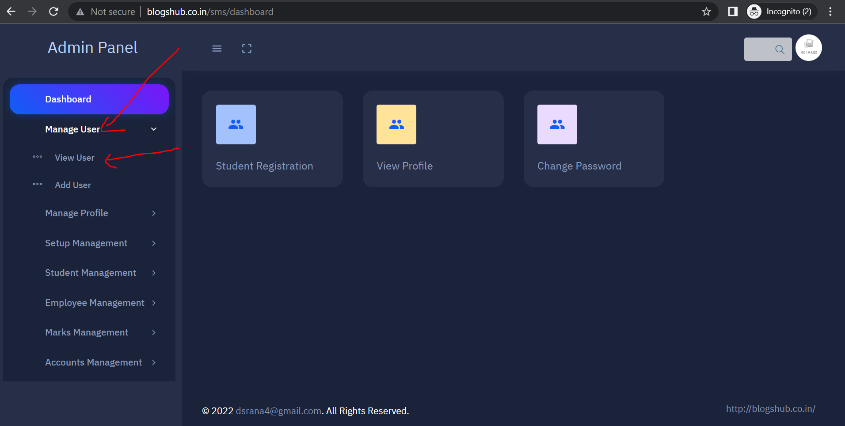

1. **In “View User” you can view, edit and delete User’s record**

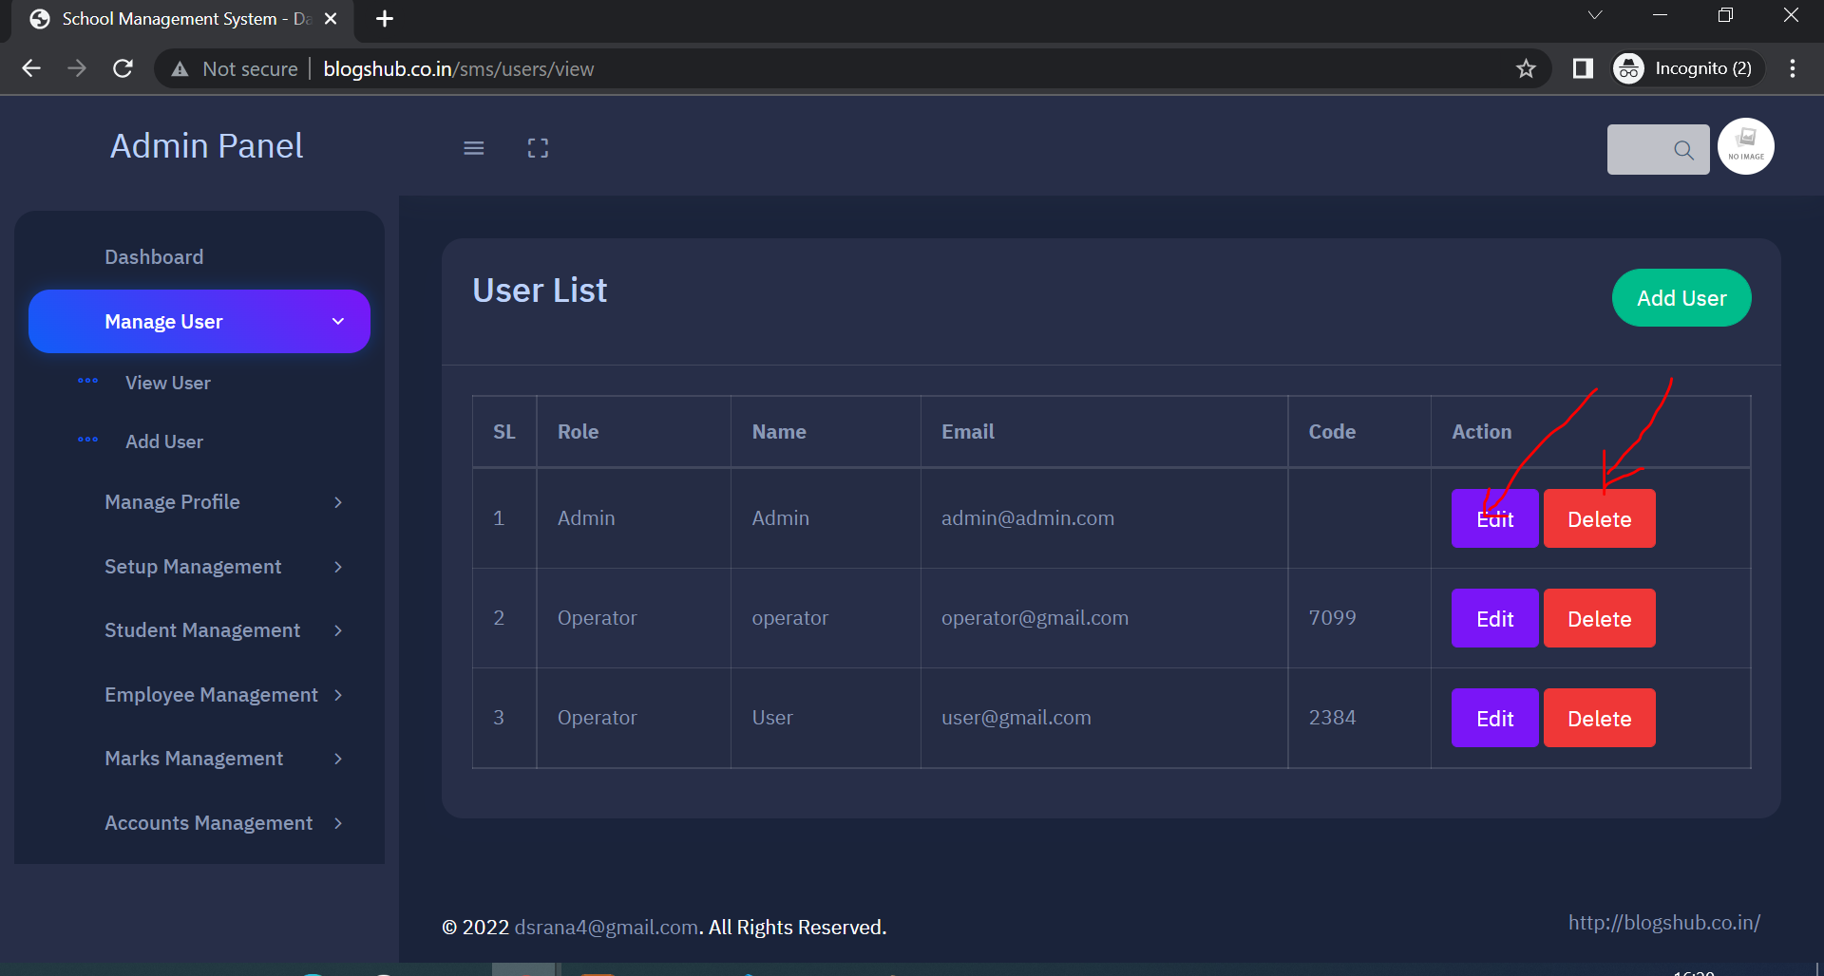

1. **Update user detail and click on “Update” button**

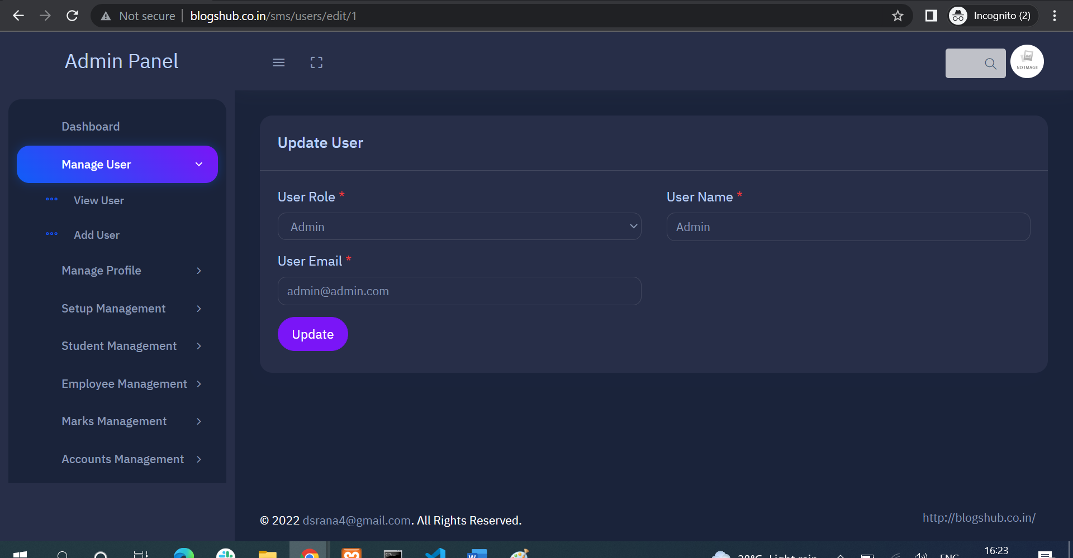

1. **Click on “Add User” tab for add new user, fill new user detail and submit the form**

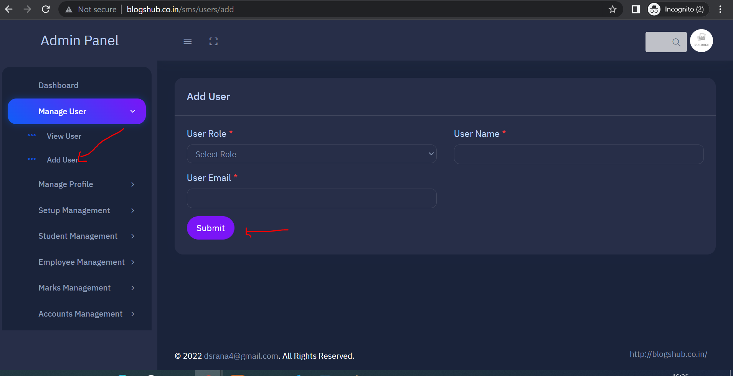

1. **Click on “Manage Profile” for view your profile and “Change Password”**

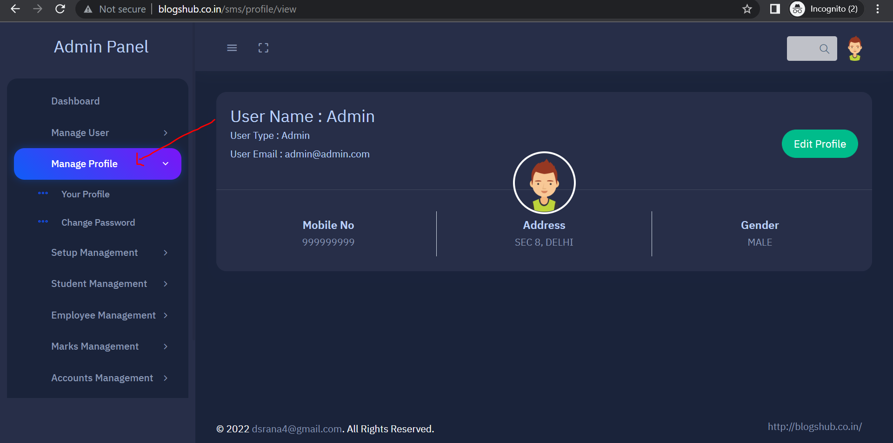

1. **Click on “Edit Profile” on right side for update your detail**

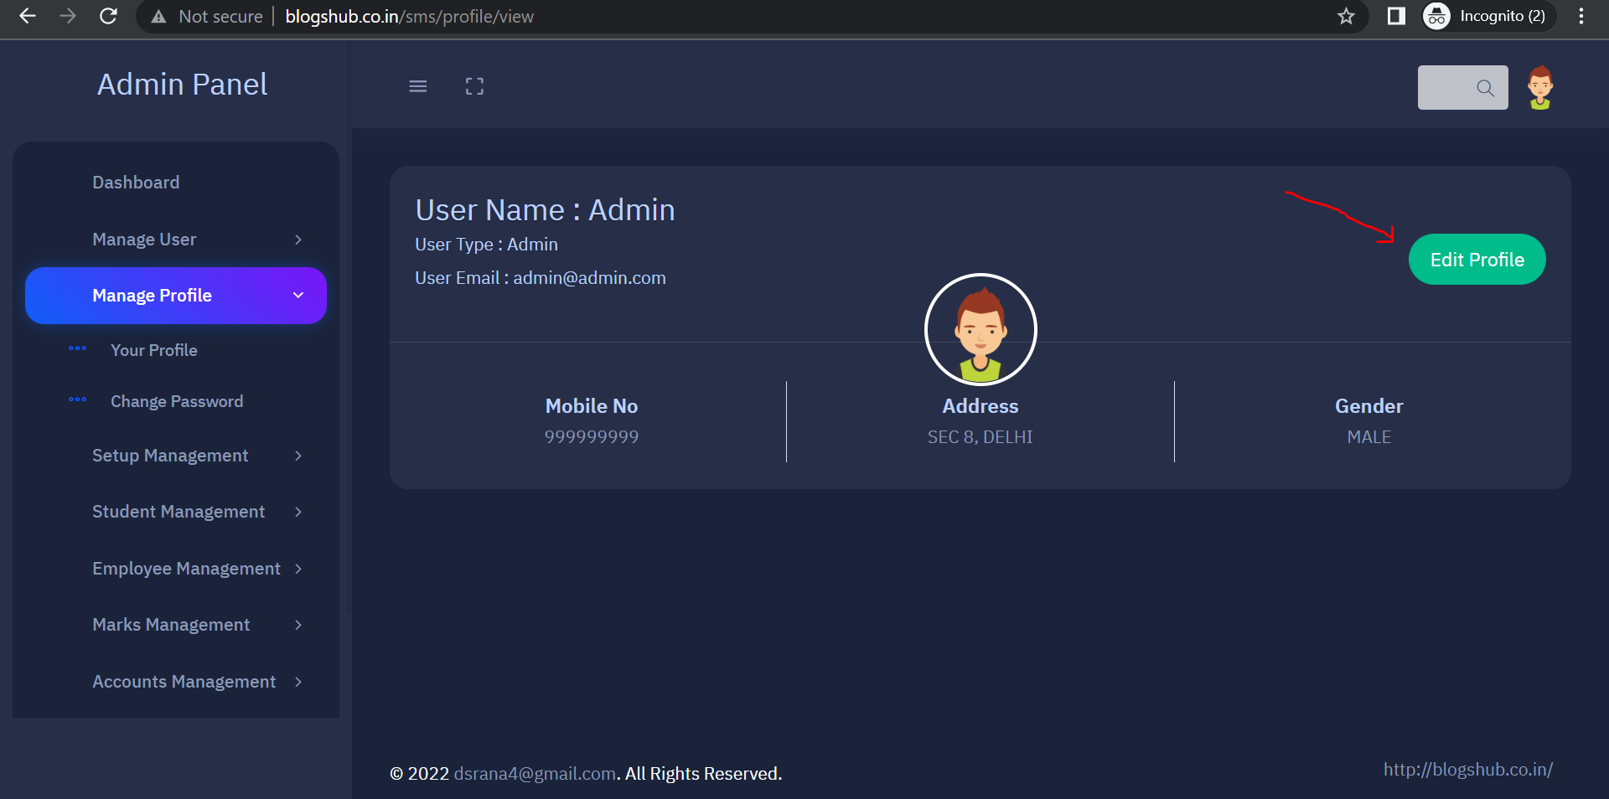

1. **Click on “Change Password” for change your account password**

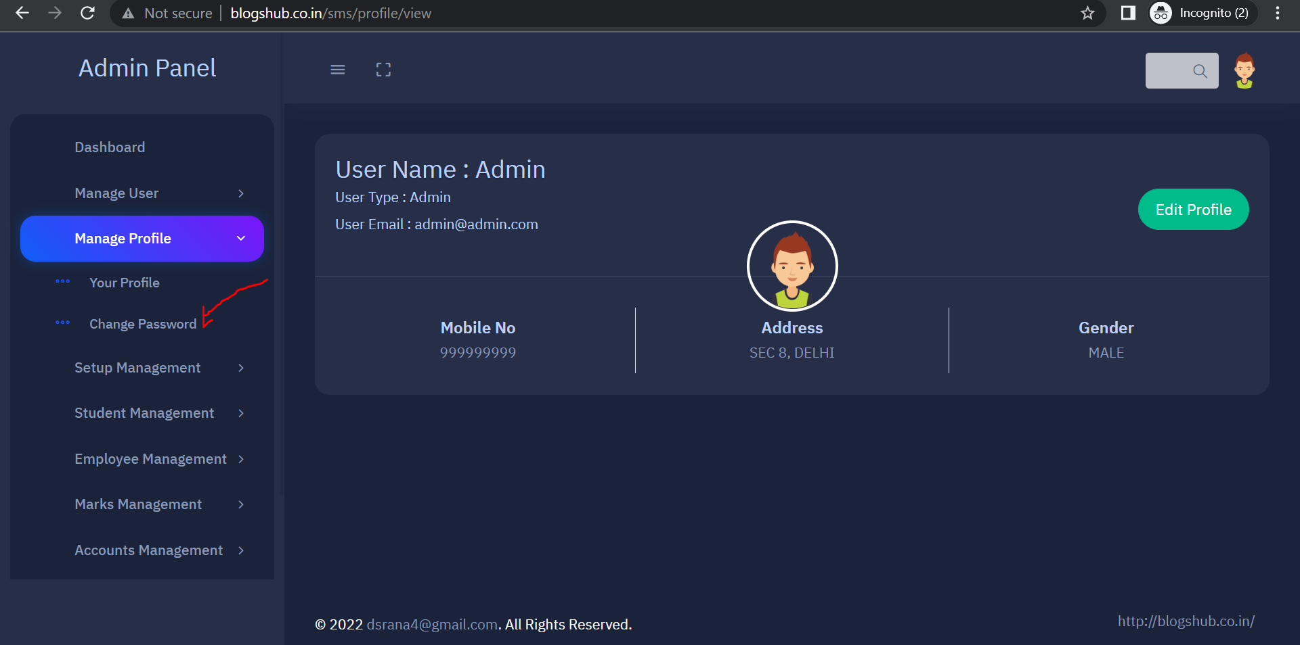

1. **Fill Current, new and confirm password and submit form**

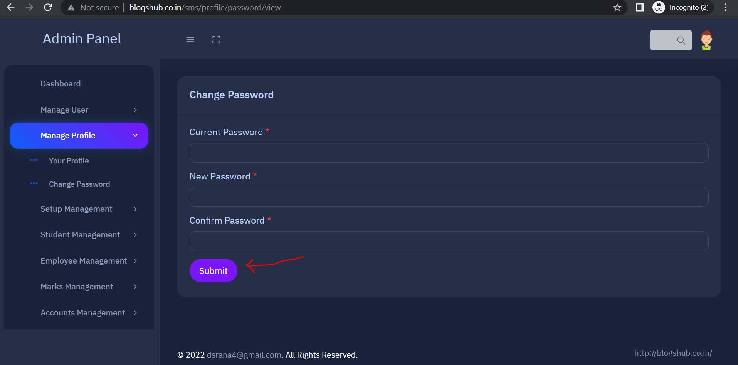

1. **Click on “Setup Management” tab for view Student, Fee and other master tab**

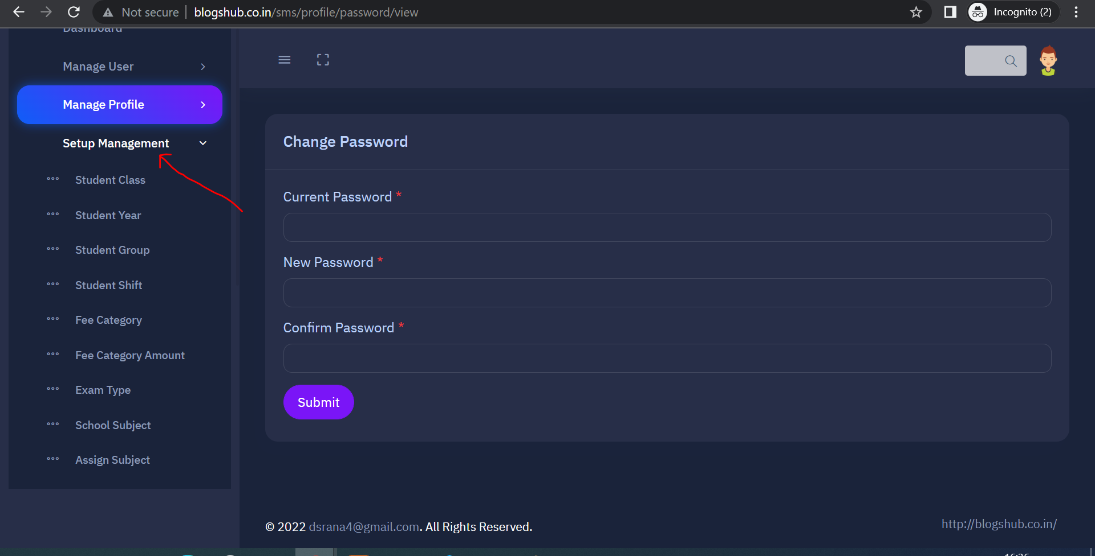

1. **Select “Student Class” tab to view all “Class List” where you can edit and delete class records.**

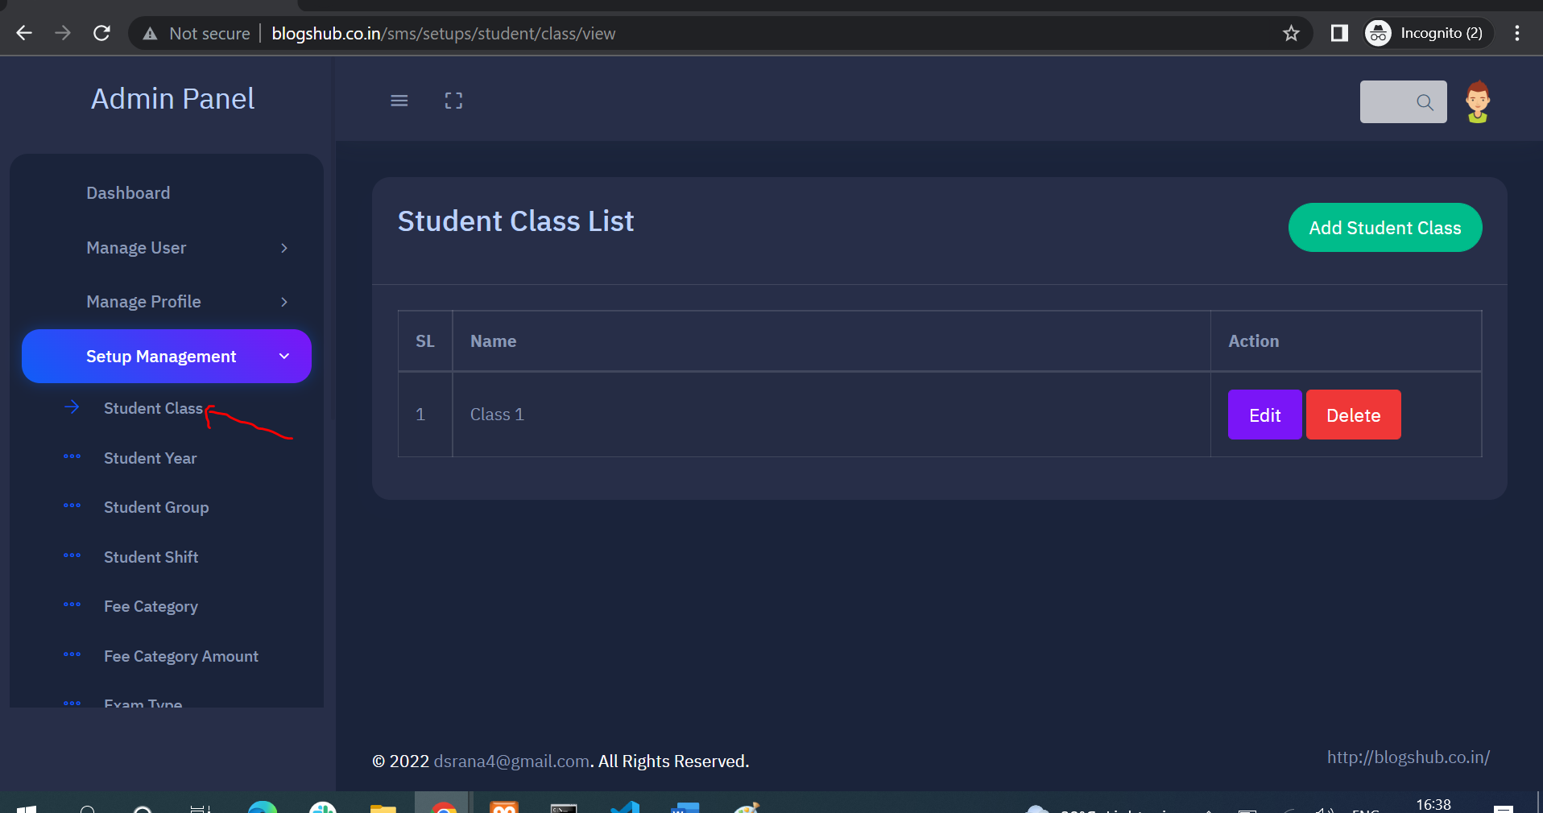

1. **Click on “Add Class” button for new class entry**

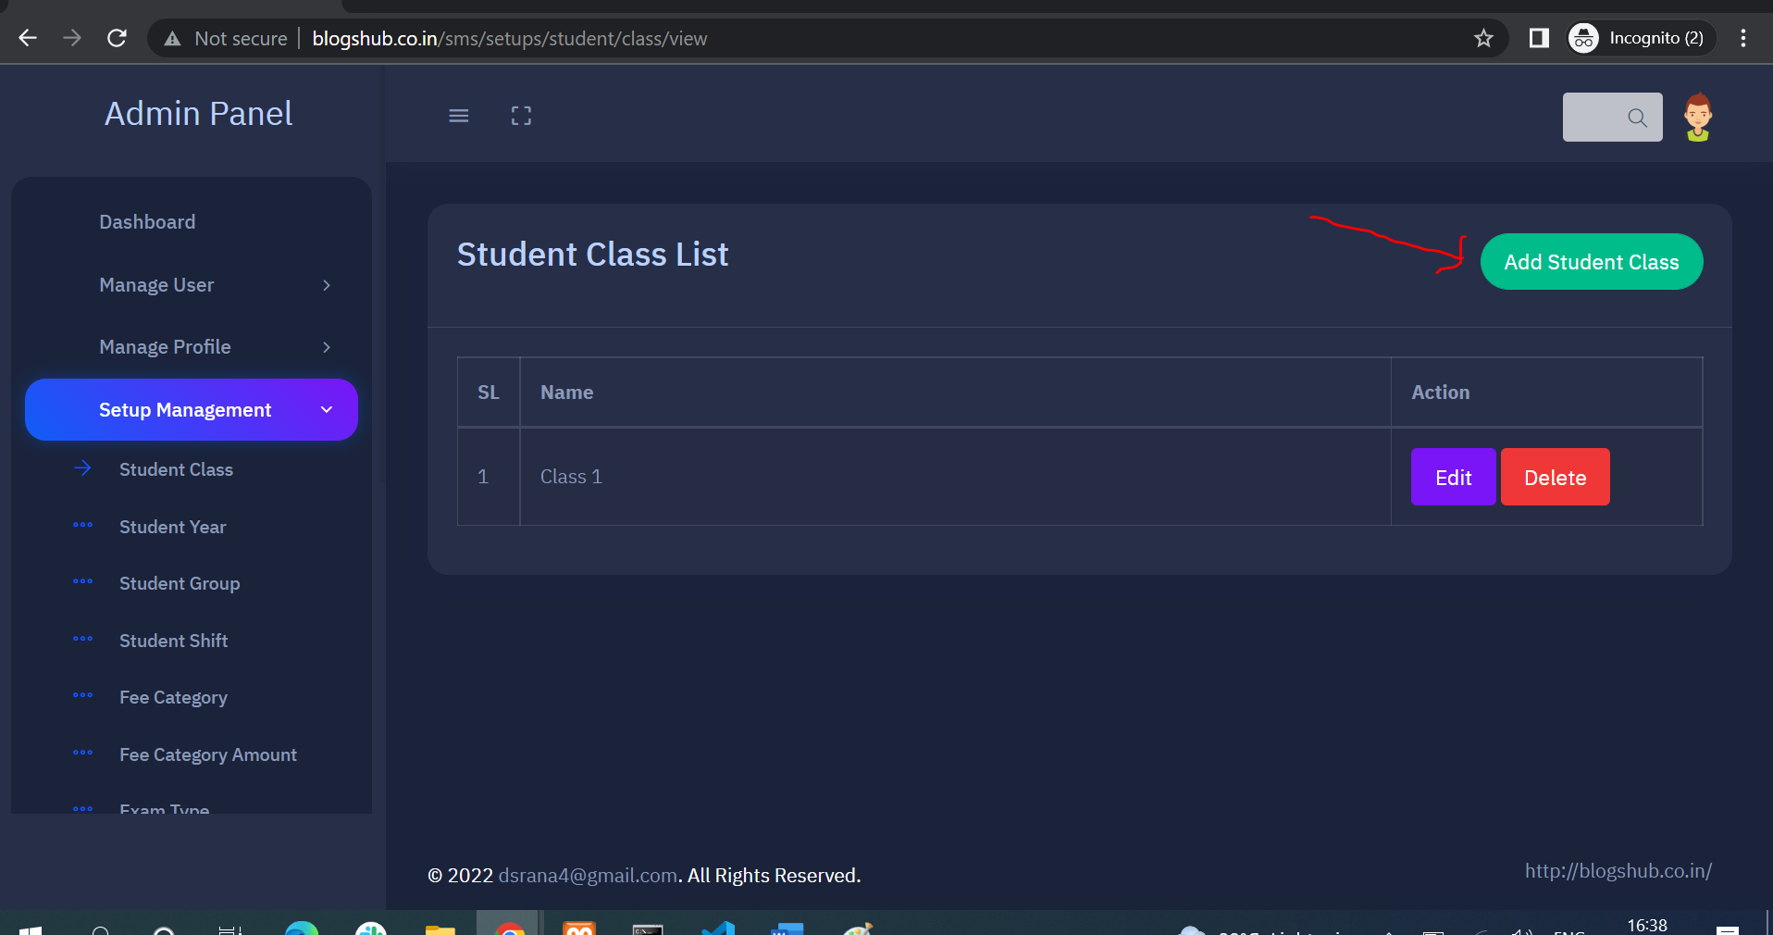

1. **Click on “Student Year” tab for view year’s list then click on “Add Year” on right side for add new year in the list**

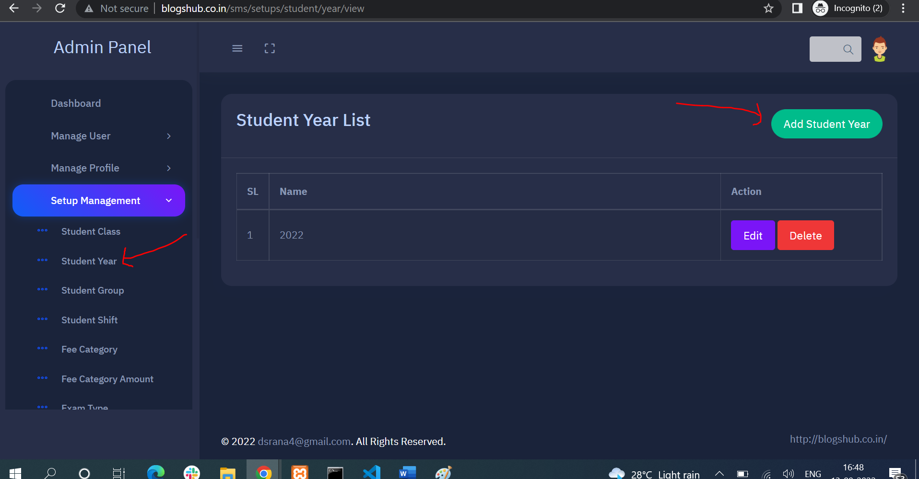

1. **Click on “Fee Category” tab to view list of Fee category to add new fee category click on “Add Fee Category” on the right side**

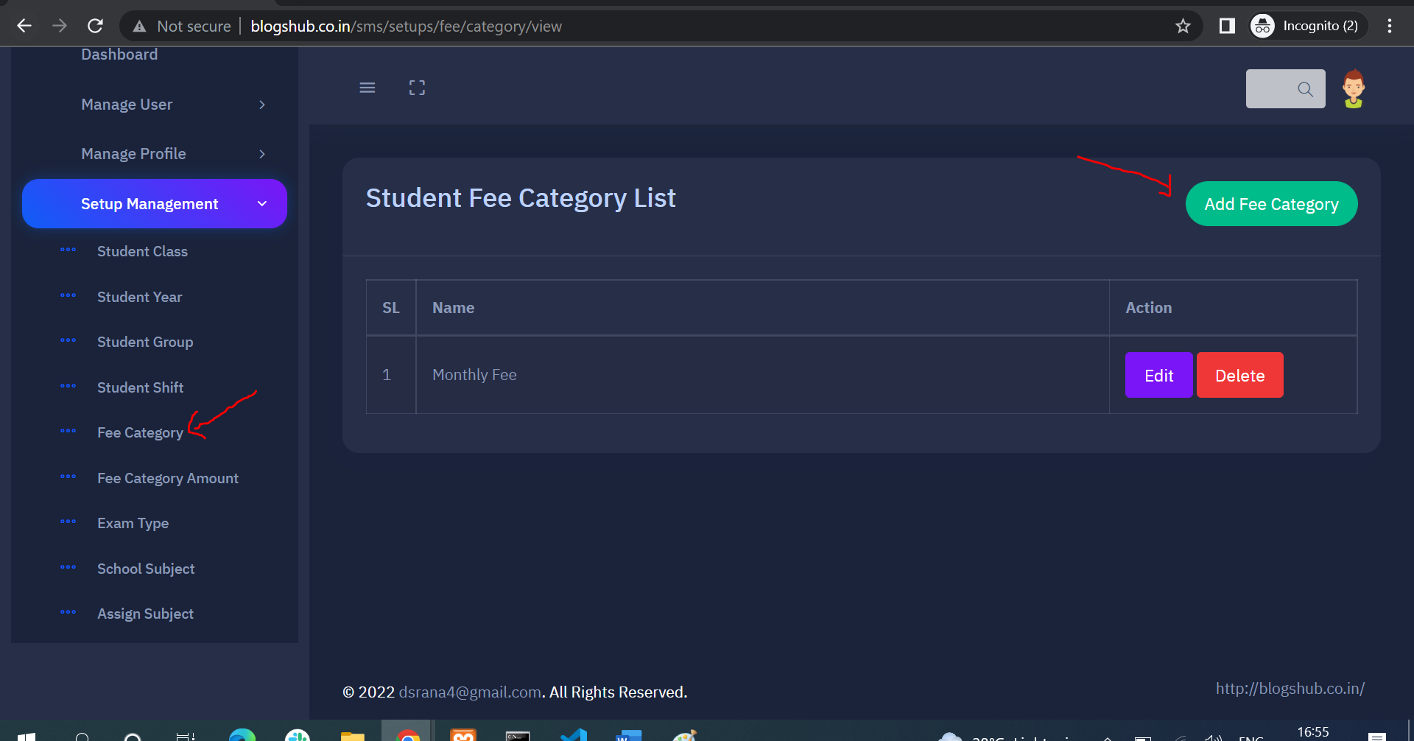

1. **Click on “Fee Category Amount” to view Fee category amount list where you can Add Amount , edit and view the detail of particular fee category**

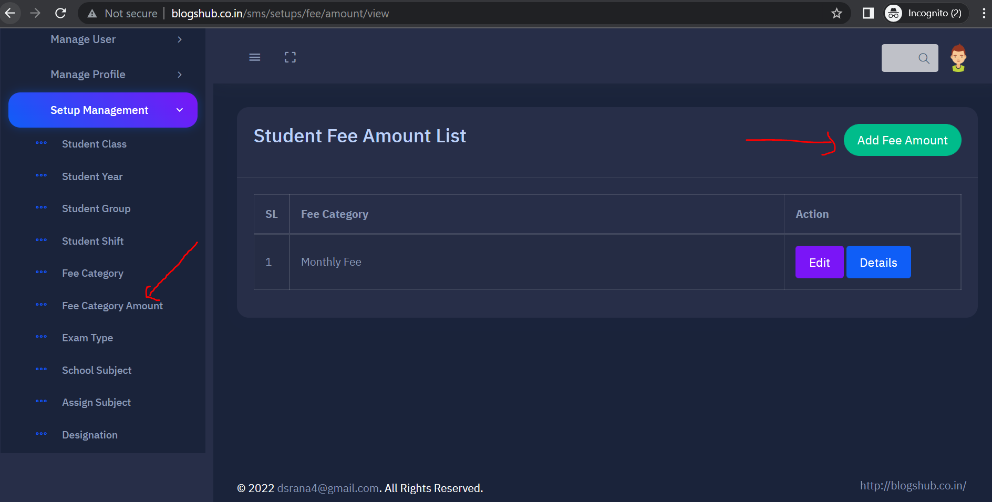

1. **Add “Category Fee Amount” and submit the form**

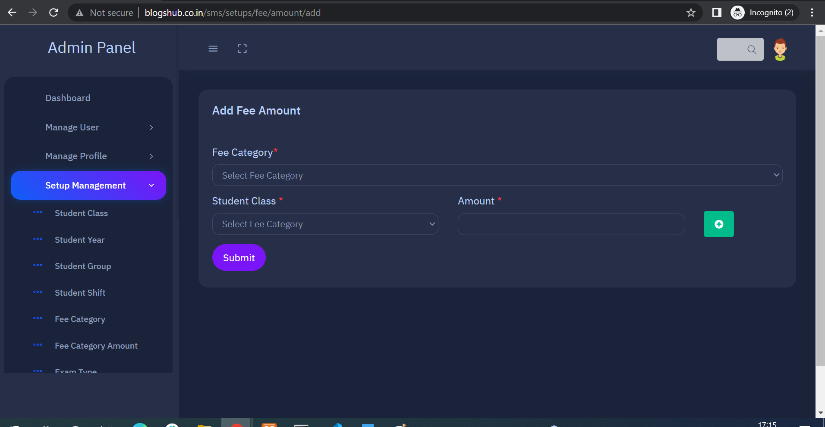

1. **You add category amount for multiple Classes**

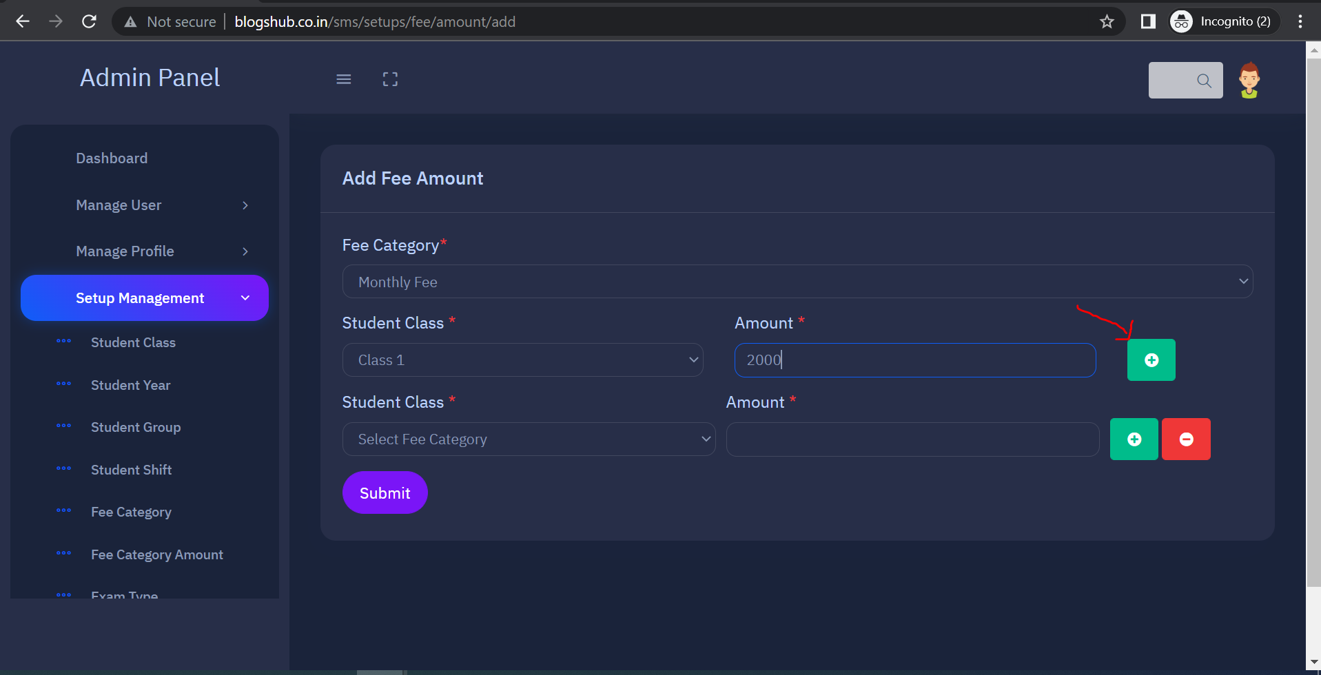

1. **View Exam type list after click on “Exam Type” tab and for add new exam type in list click on “Add Exam Type” button on right side**

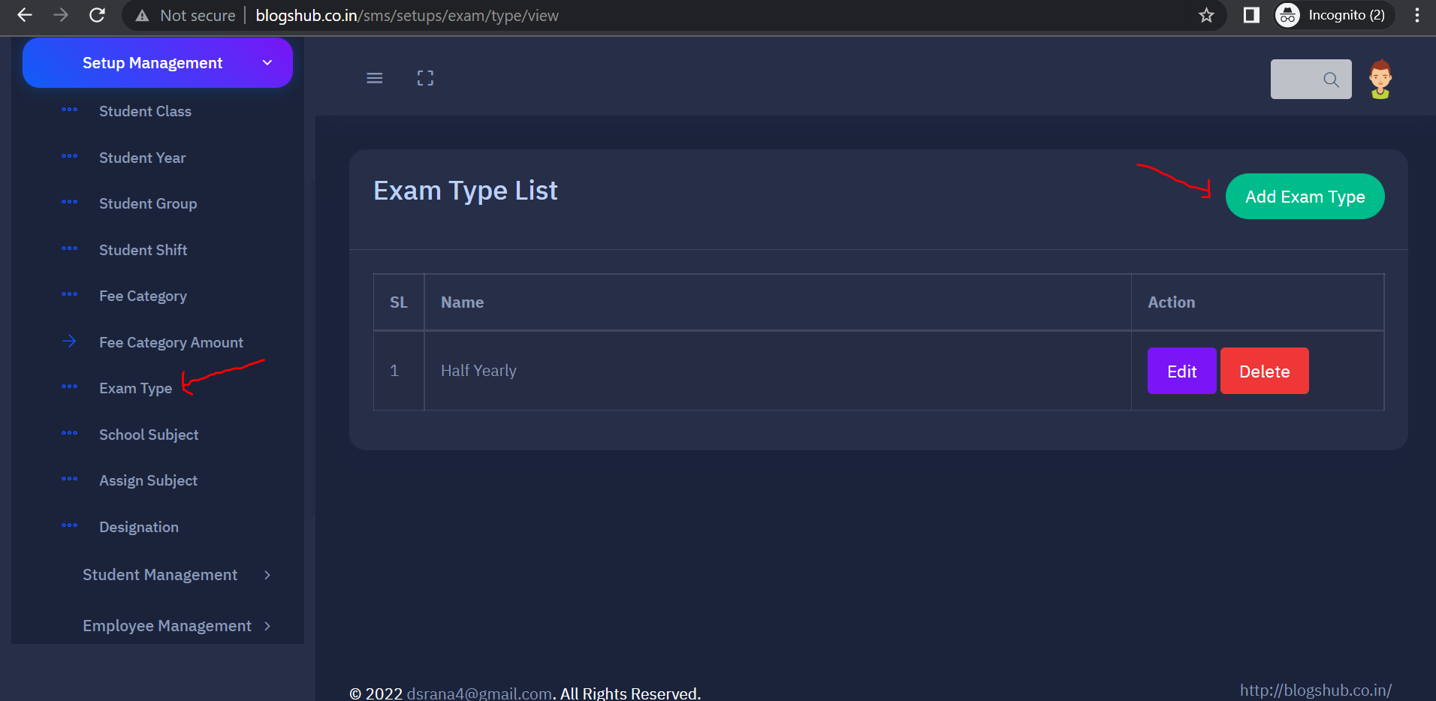

1. **Click on “School Subject” tab for view the list of Subjects where you can edit and delete subject record. For add new subject click on “Add Subject” button on right side**

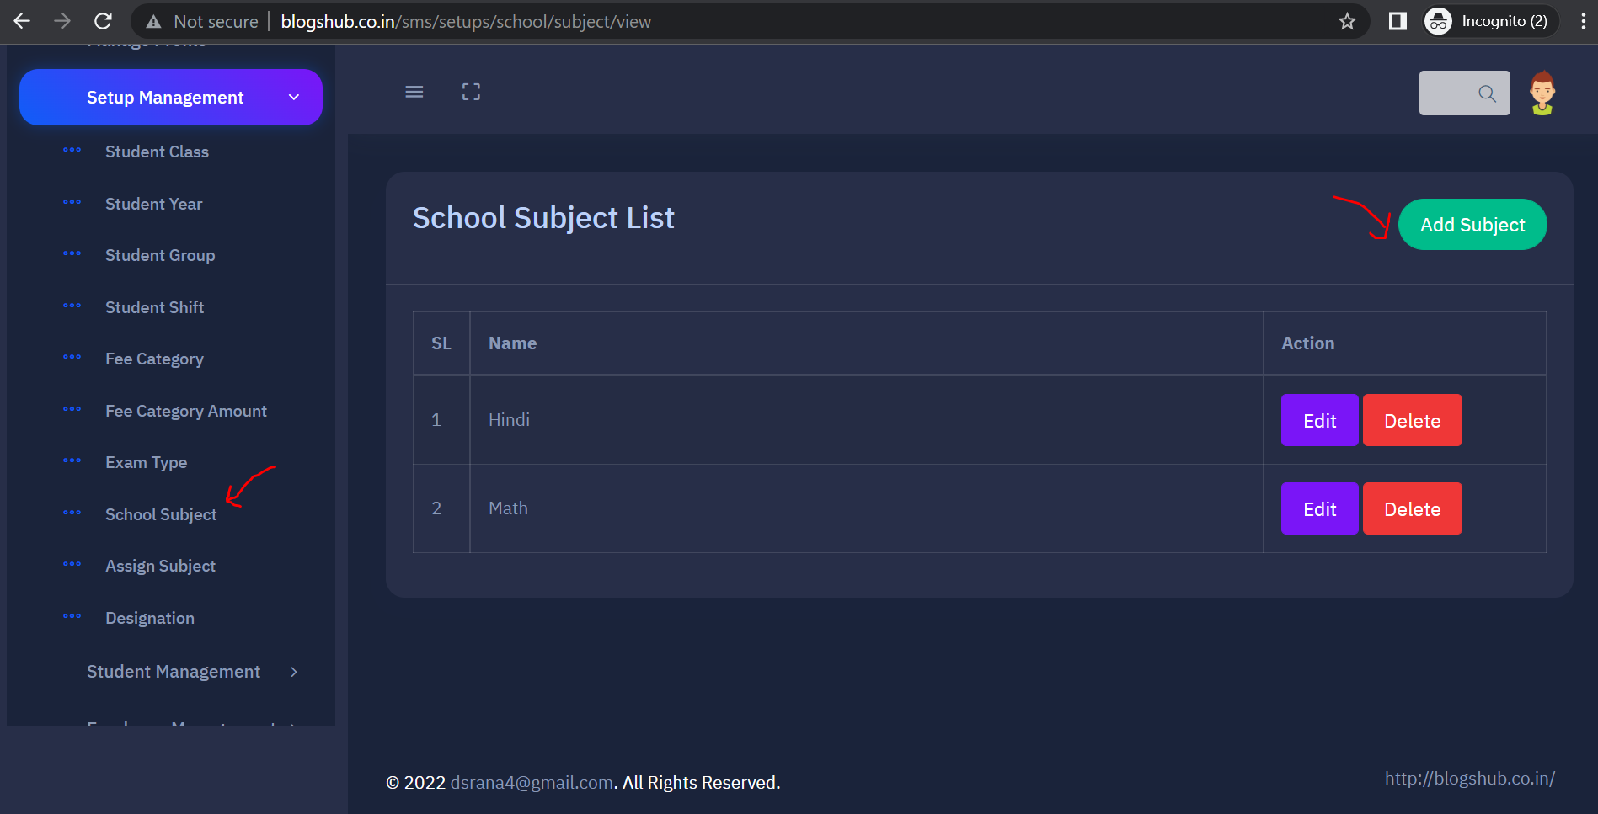

1. **Fill Subject name and submit the form**

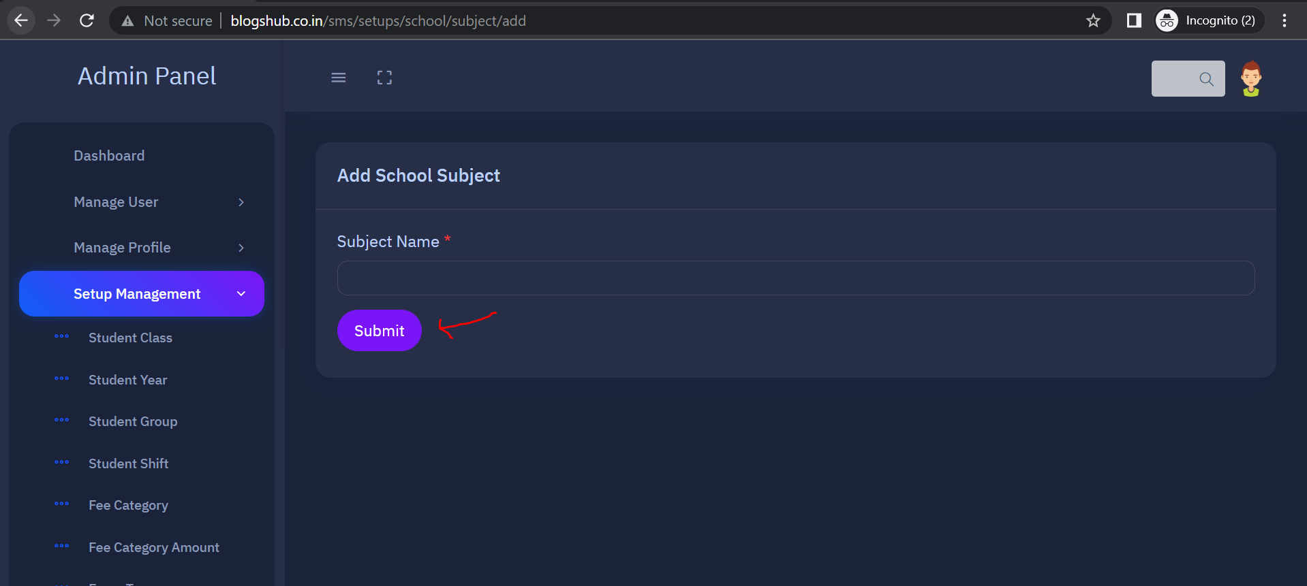

1. **Click on “Assign Subject” tab to view the “Assign Subject List” where you can Edit and view the subjects detail with marks**

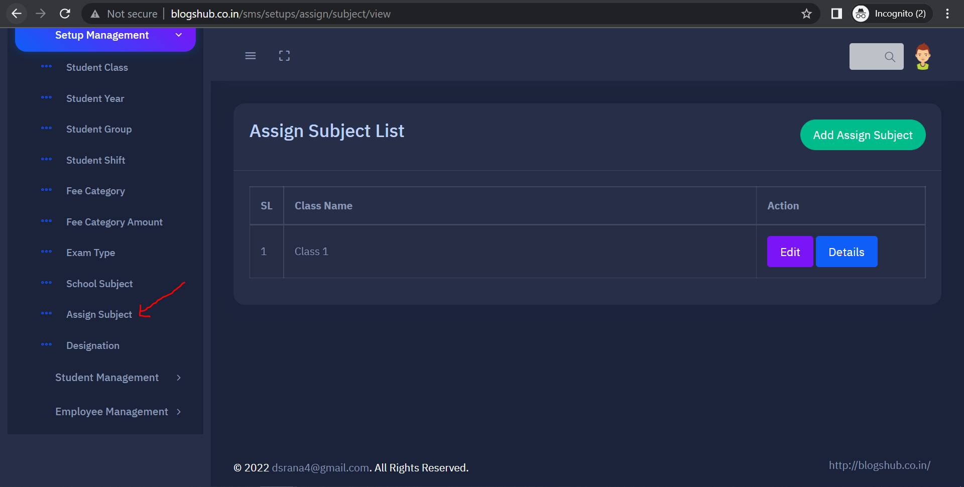

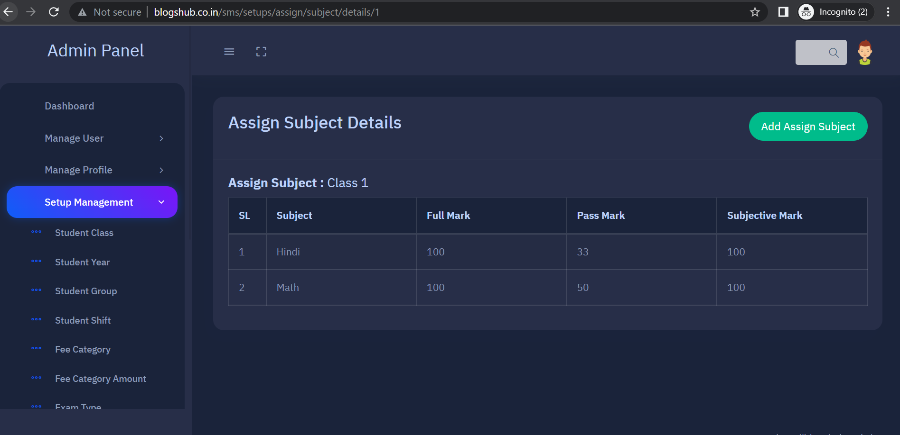

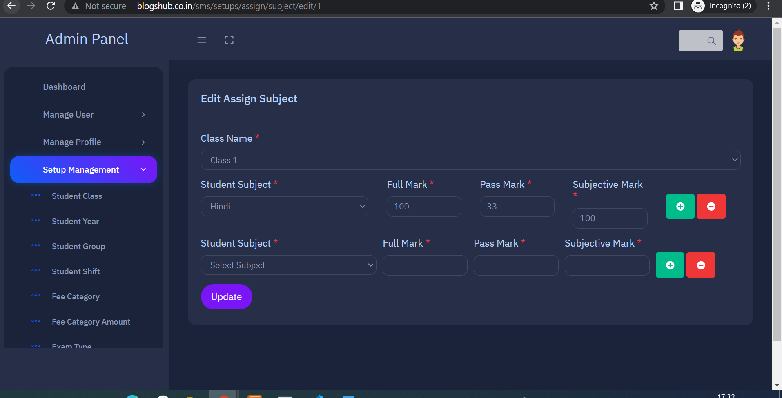

1. **Click on “Designation” to view and add Designation inside “Setup Management”**

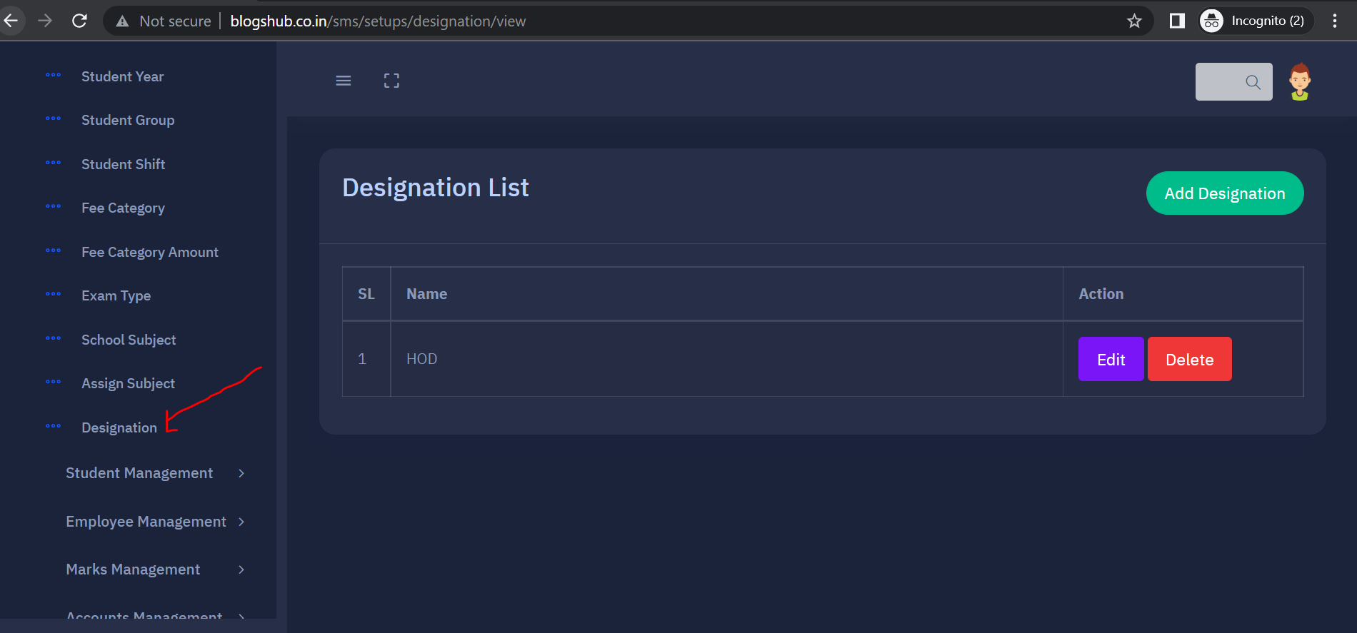

1. **Click on “Student Management” for manage Student area**

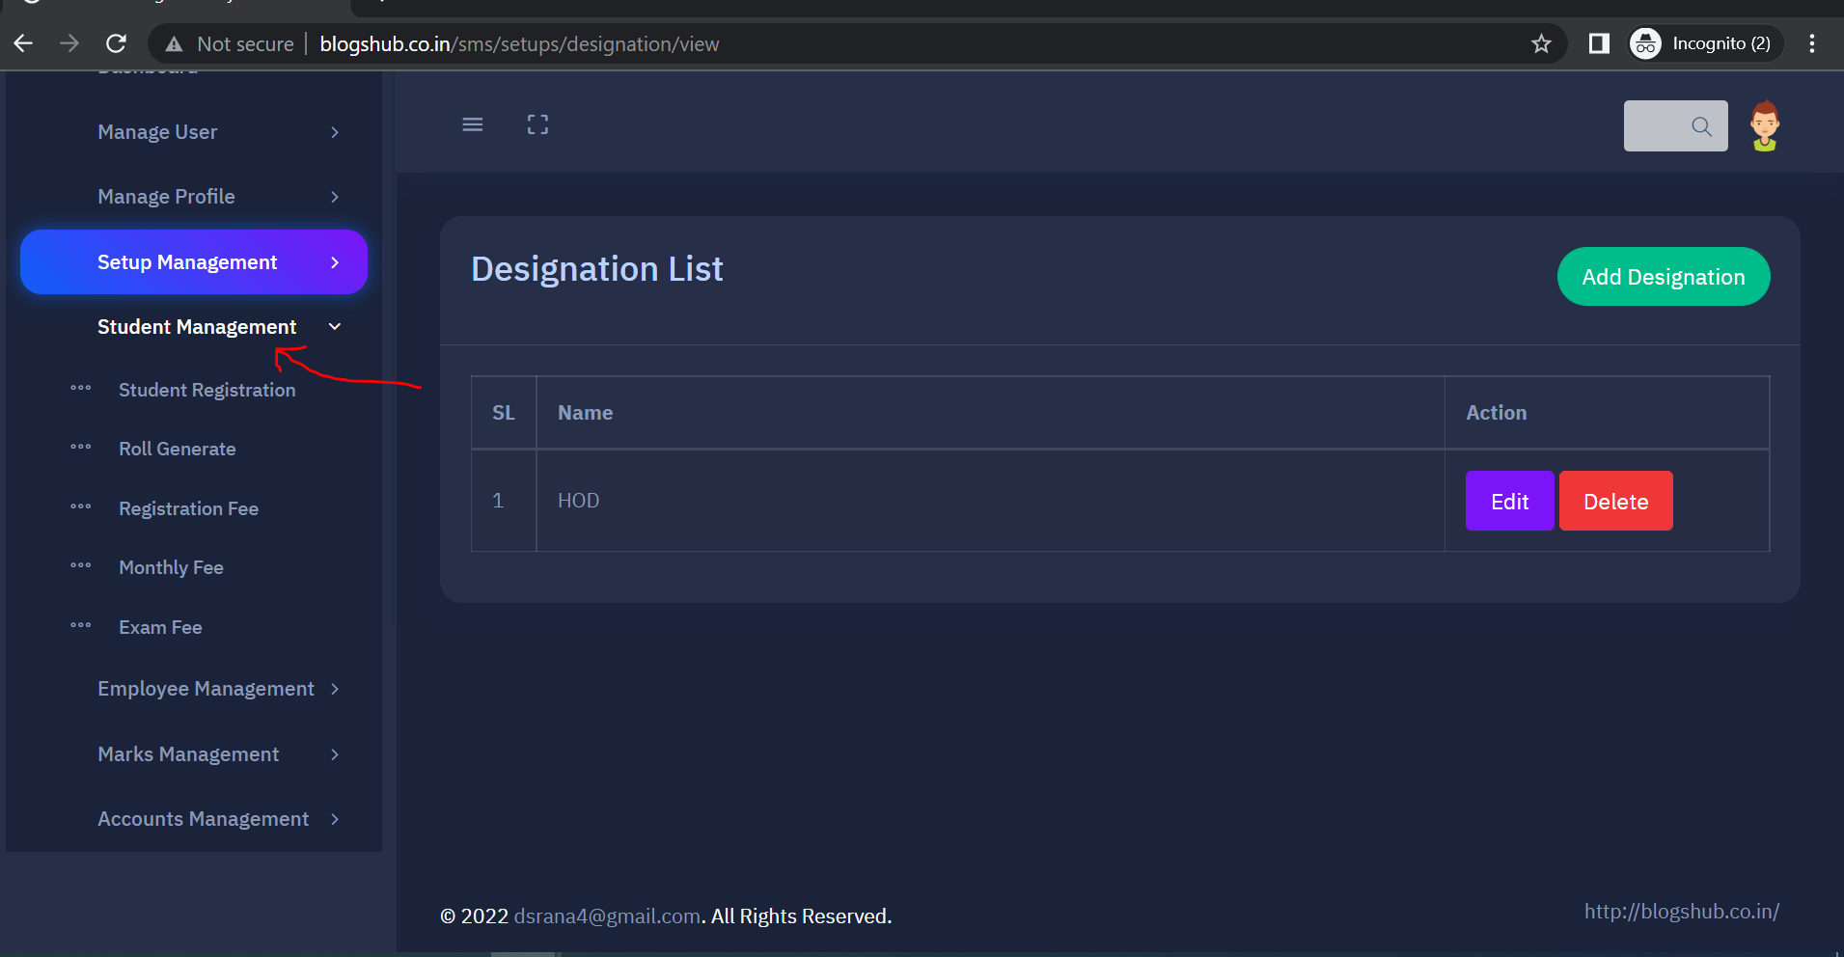

1. **For view Student list and filter student by year and class click on “Student Registration” tab**

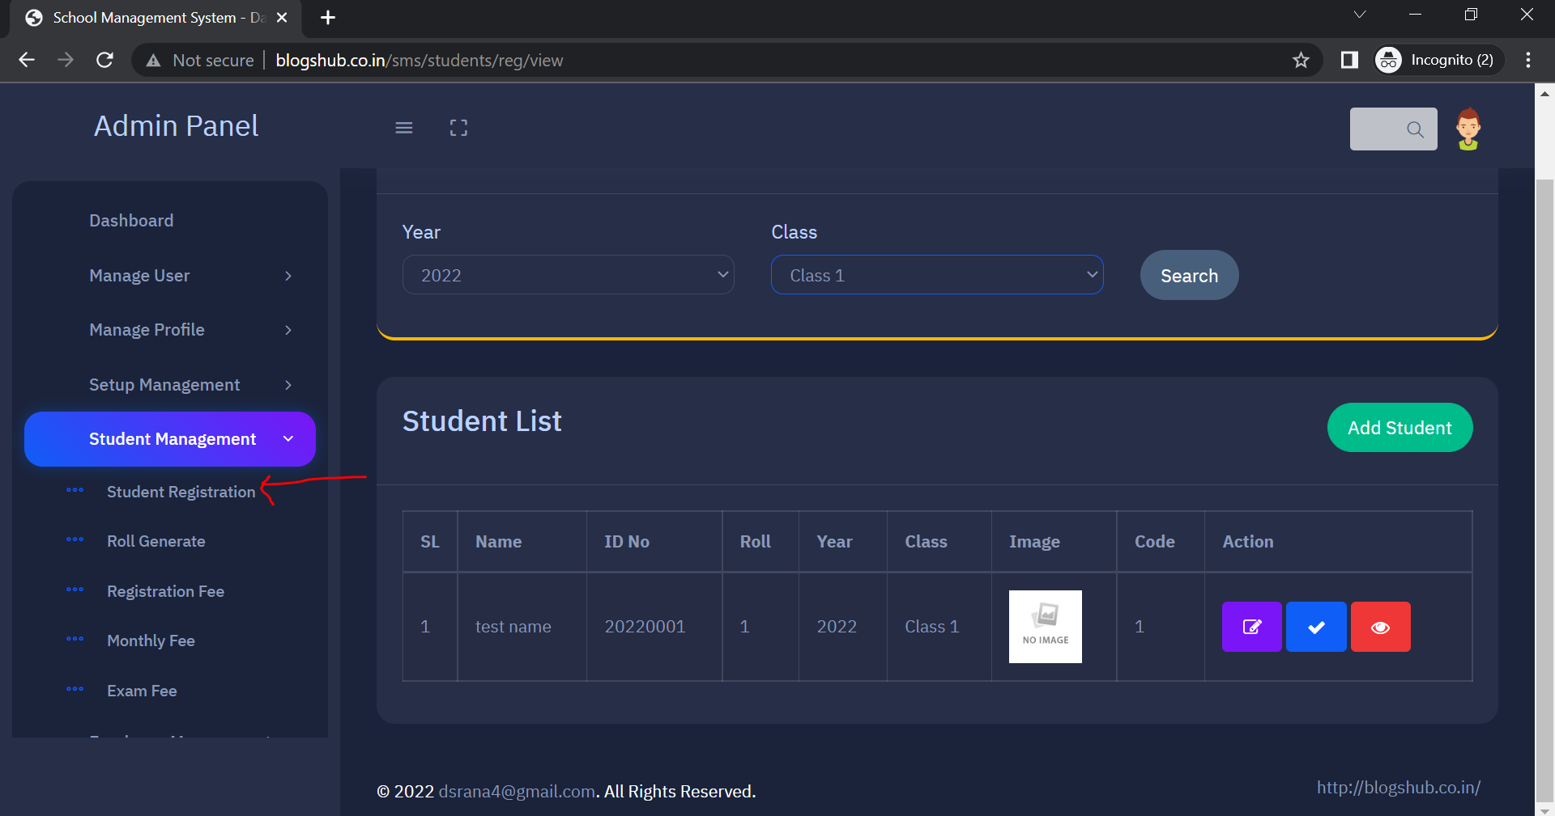

1. **Click on “Add Student” button on right side for add new student**

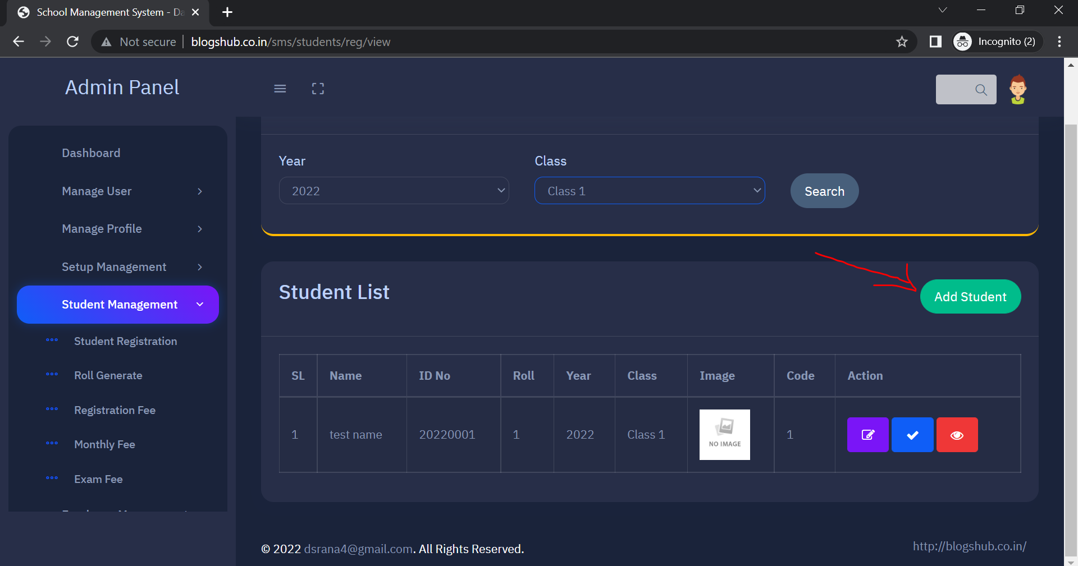

1. **Fill and submit the form for Student registration**

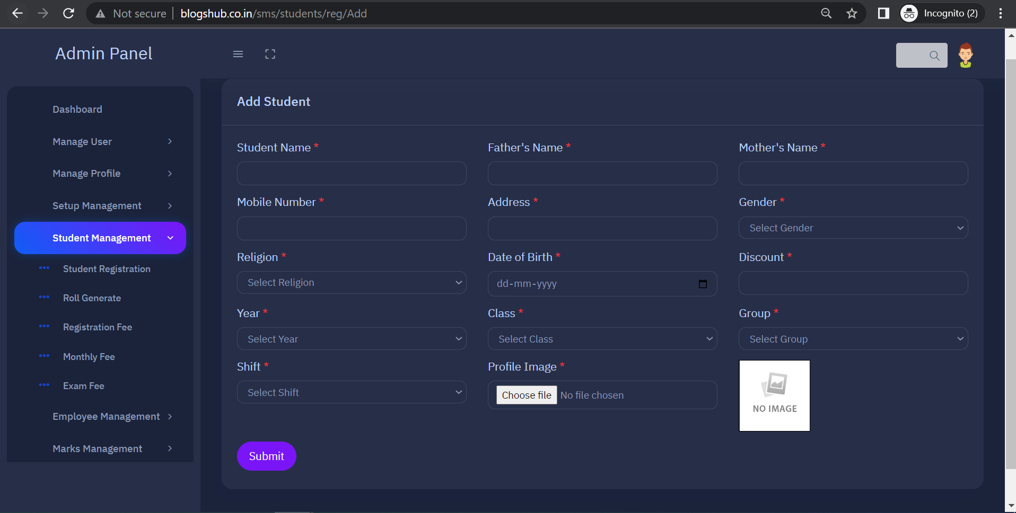

1. **Click on Promote button to promote student in new class**

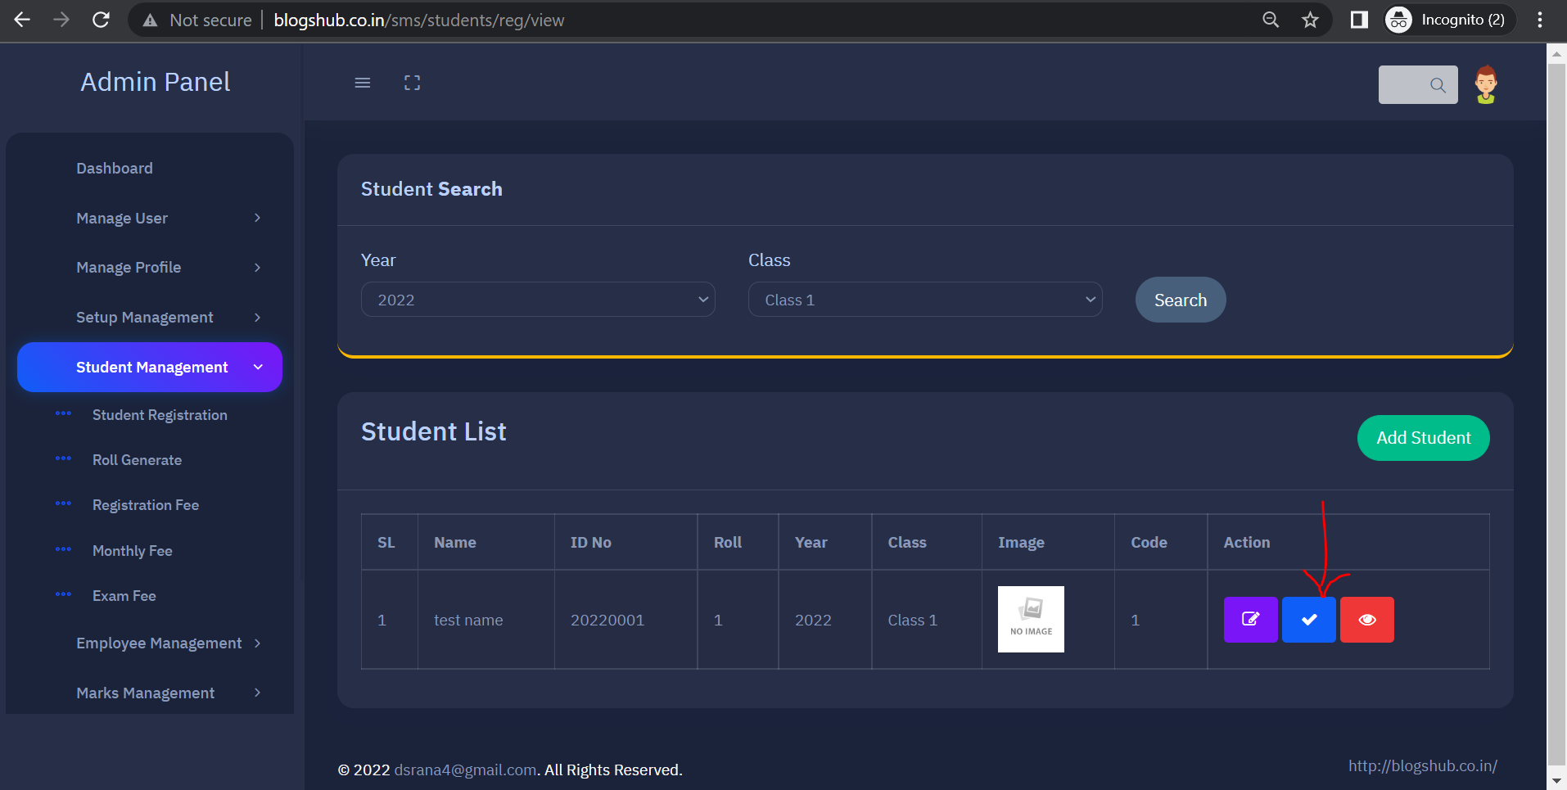

1. **Click on view icon for generate a PDF of student detail**

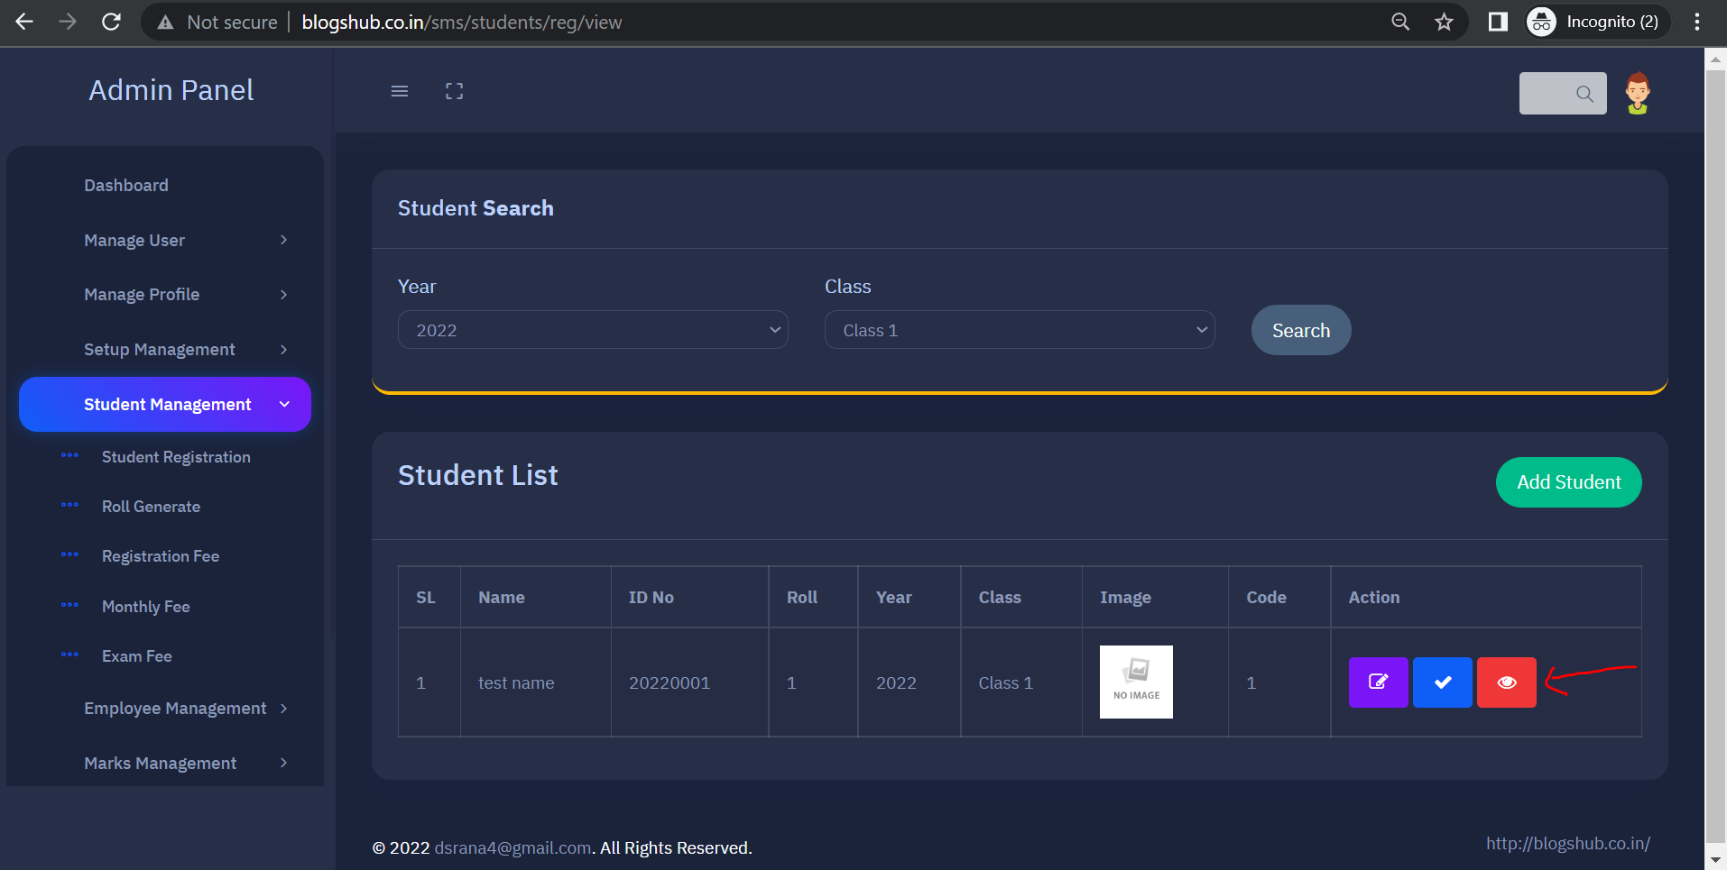

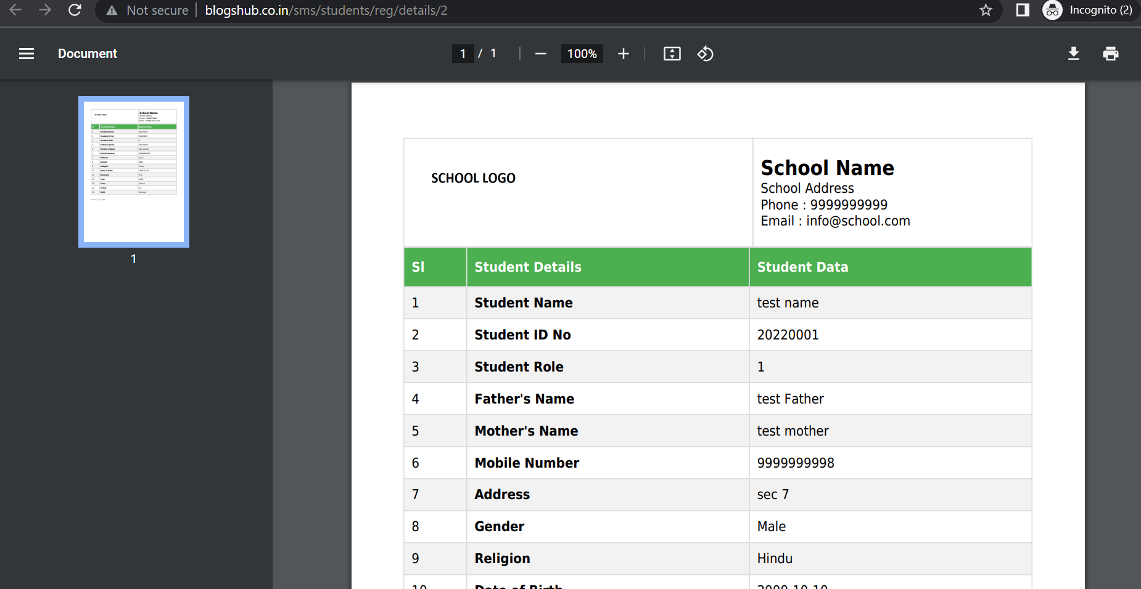

1. **For generate student Roll Number click “Roll Generate” tab then search student year and class wise enter roll number in “Roll” field and click “Roll Generate” button**

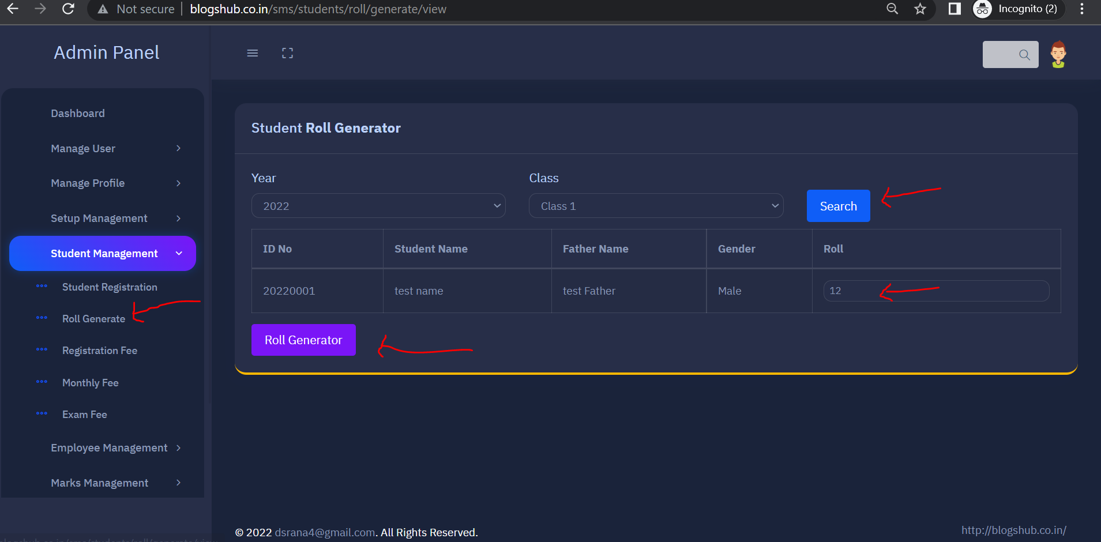

1. **For view and get Student Registration Fee slip click on “Registration Fee” tab then search student by year and class wise and click on “Fee Slip” button on right side to get pdf**

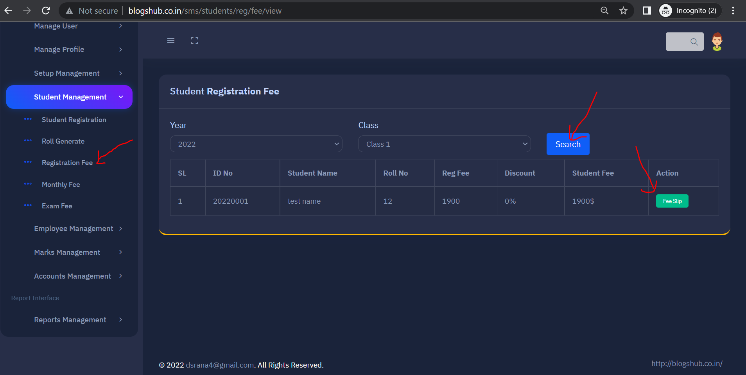

1. **Click on monthly fee tab to get students Monthly Fee detail**

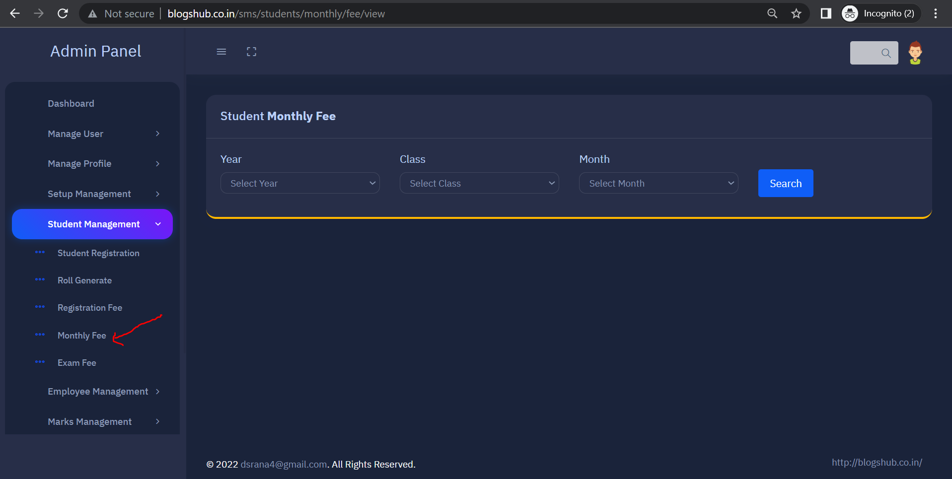

1. **For view student Exam fee click on “Exam Fee” tab**

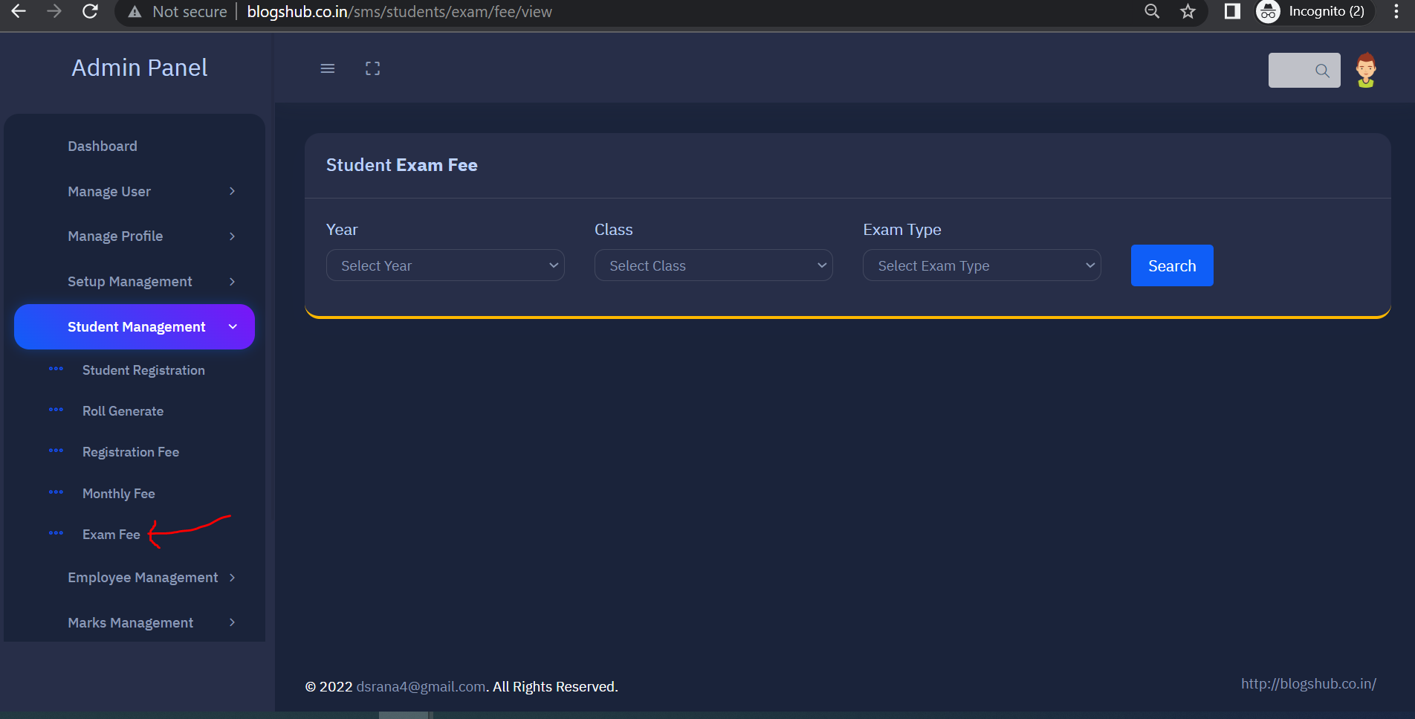

1. **For employee Section click on “Employee Management” tab**

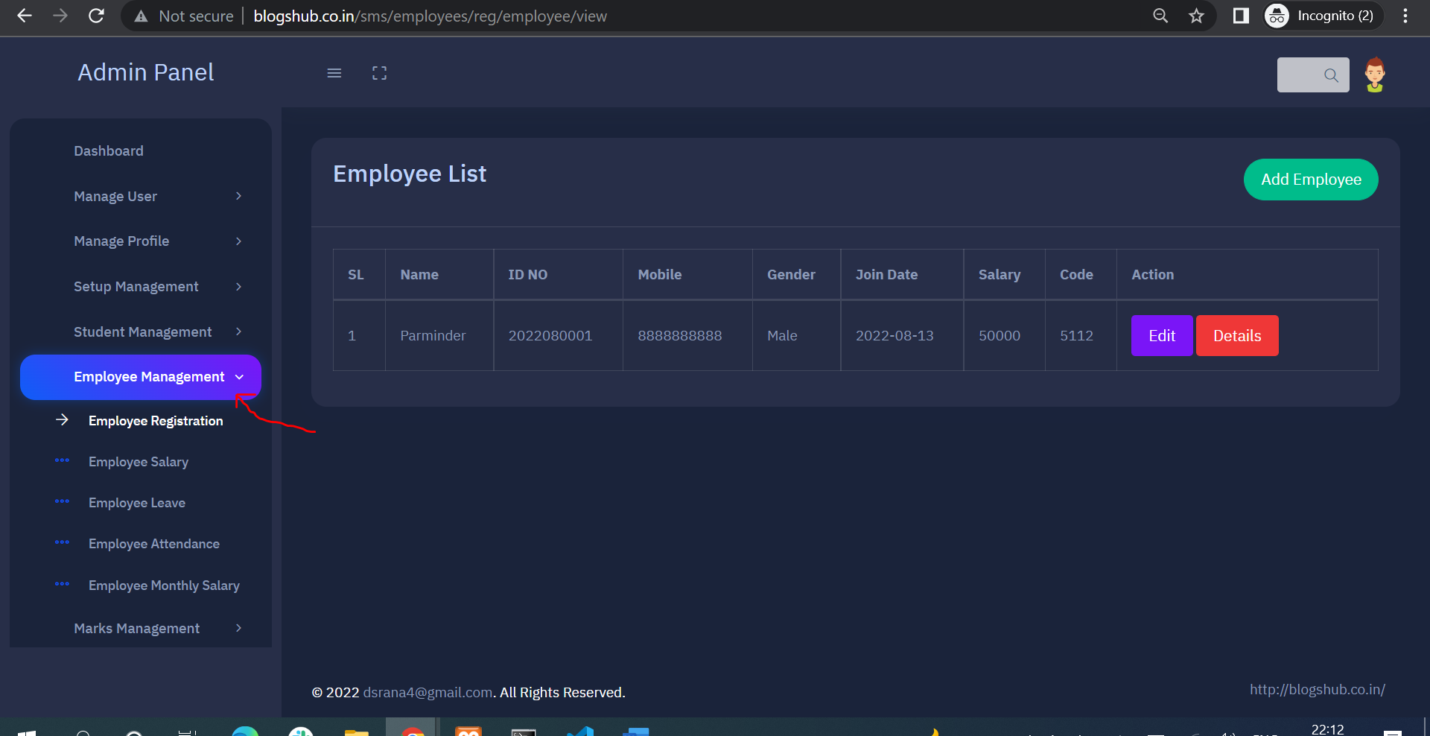

1. **Click on “Employee Registration“ tab to view employee list , where you can edit employee and can check employee detail using “Detail” button**
2. **Click on “Add Employee” button for add new employee detail.**

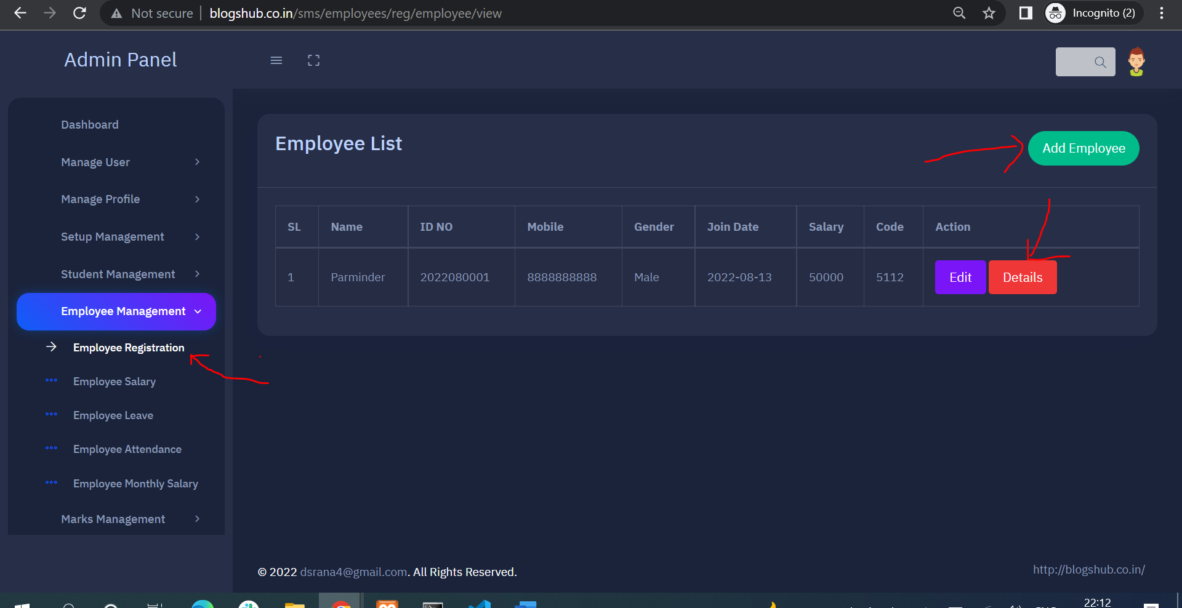

1. **Fill employee detail and submit the form**

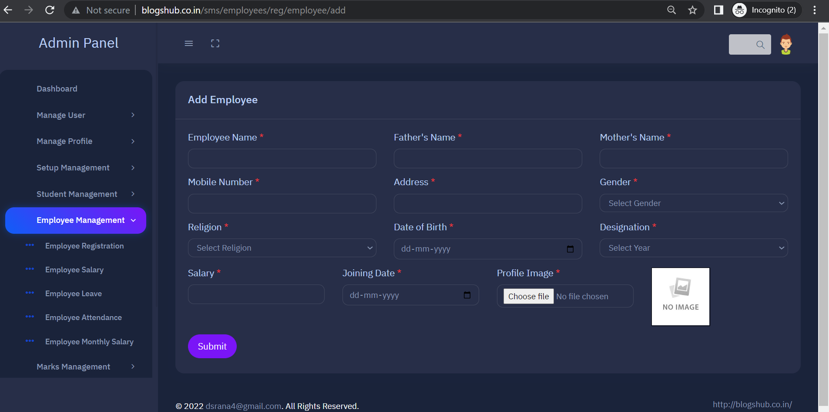

1. **Click on “Employee Salary” tab for view all employee salary list**

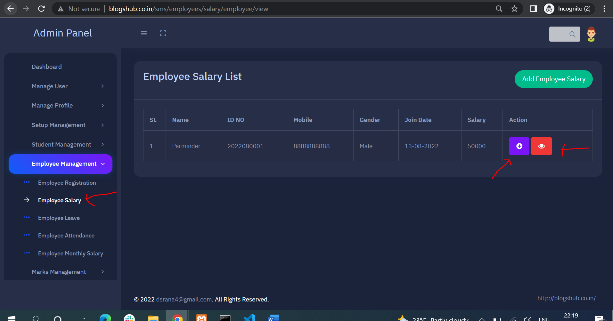

1. **Click on plush icon to add employee increment amount, fill amount and date and submit the form**

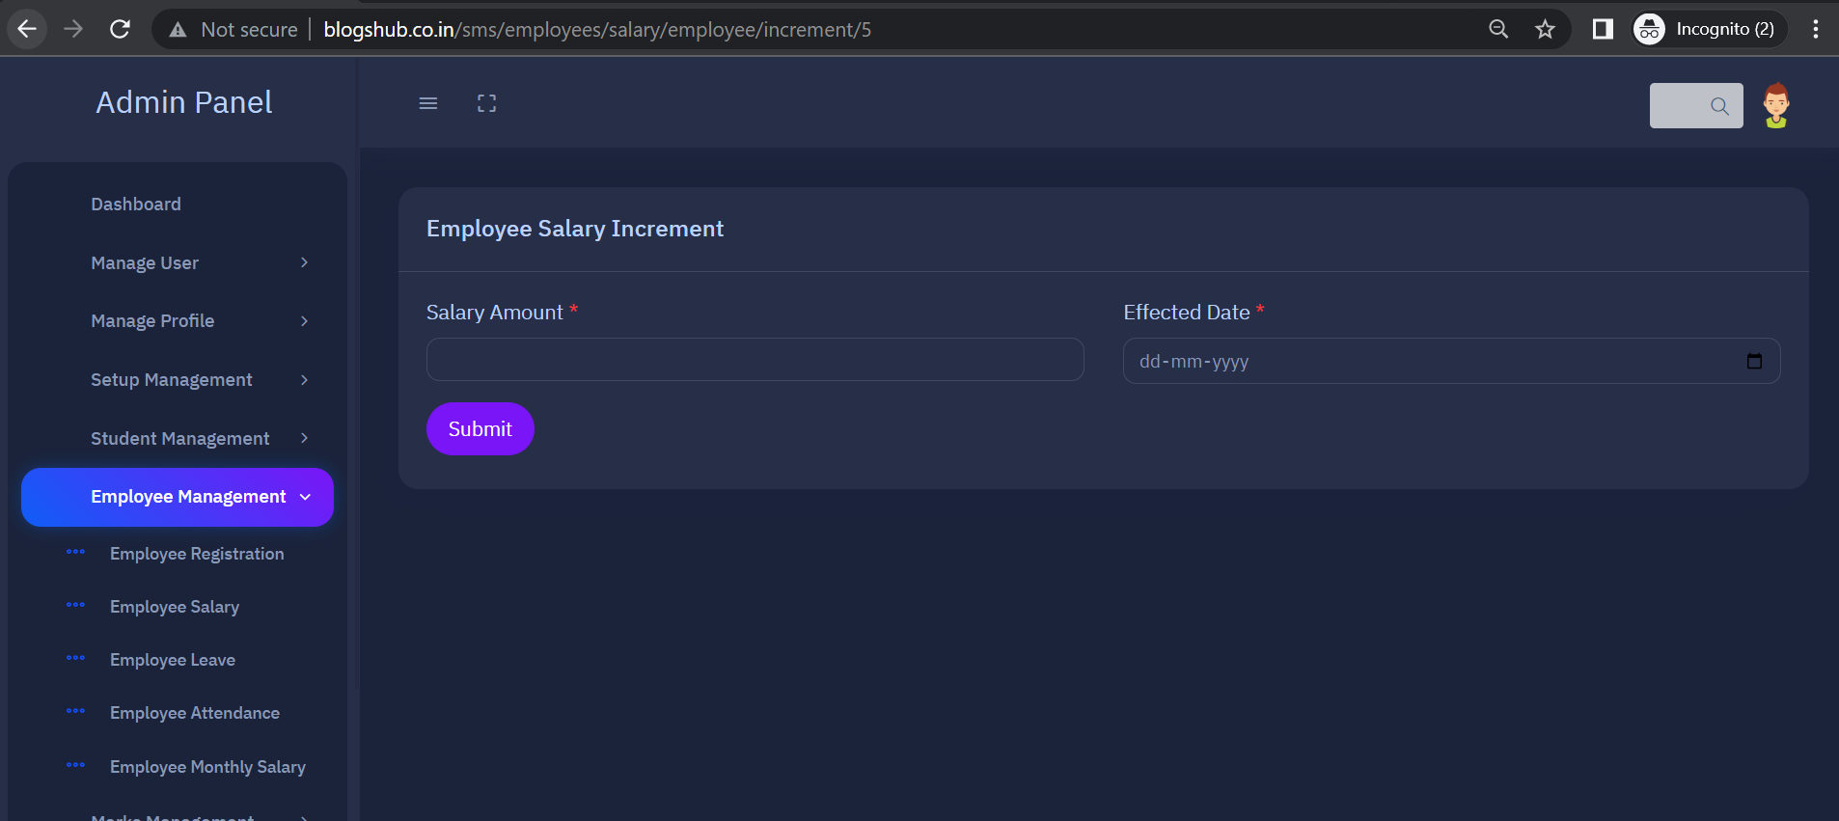

1. **Click on view icon to view increment and present salary amount**

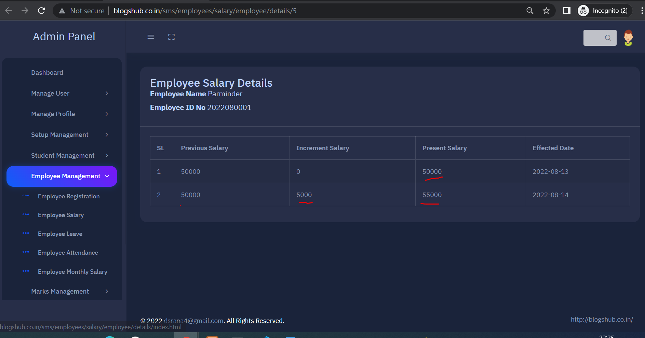

1. **Click on “Employee Leave” tab for view employee leave list**

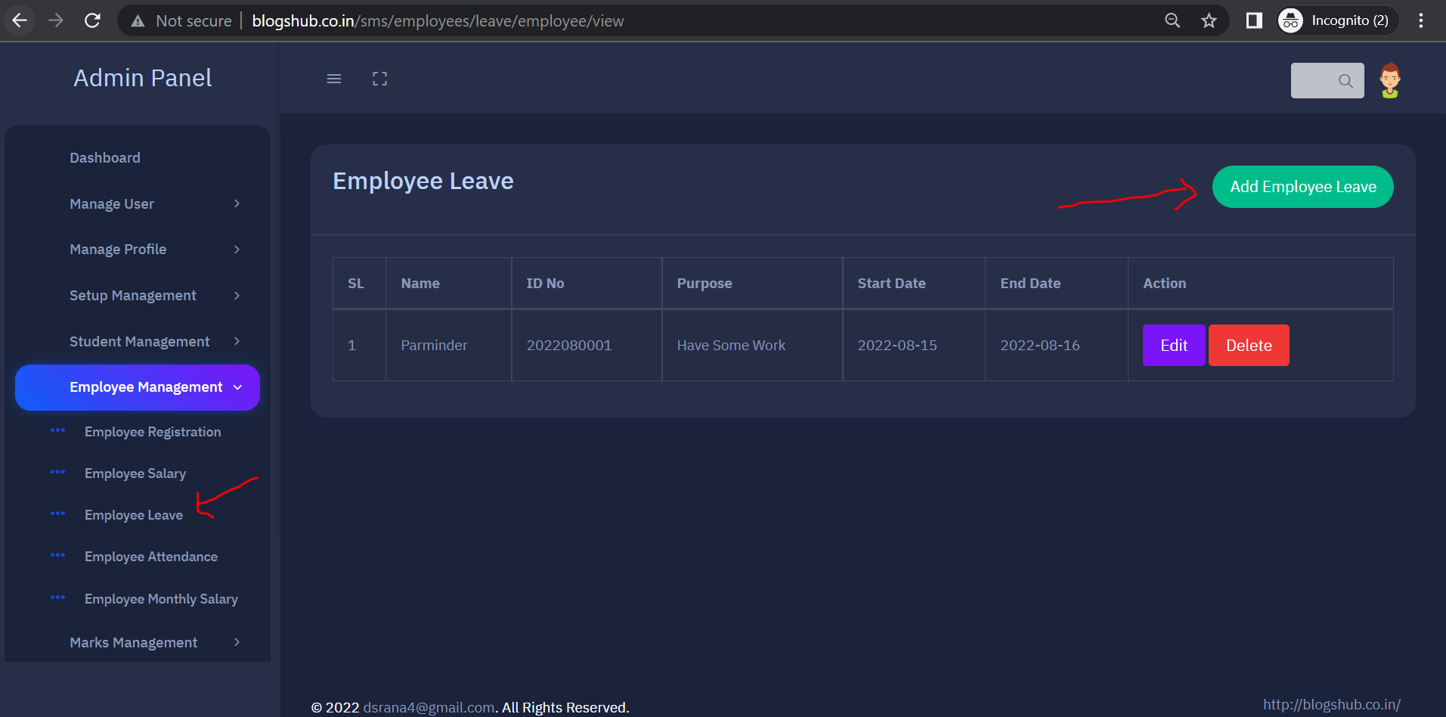

1. **Click on “Add Employee Leave” button on right side for add employee leave, fill leave detail and submit the form**

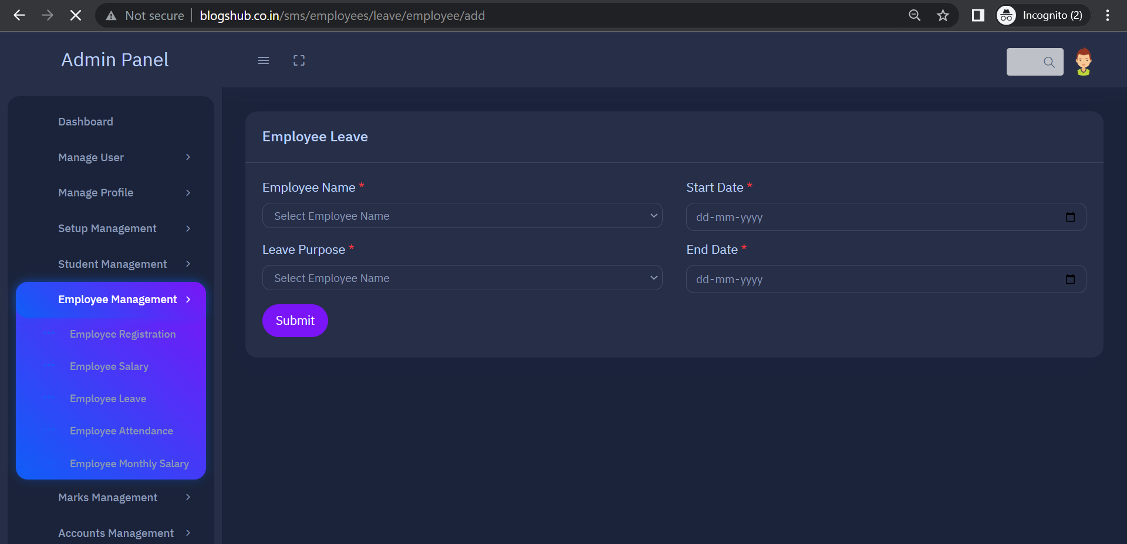

1. **Click on “Employee Attendance” tab to view Employee Attendance list, where you can view and edit attendance and click on “Add Attendance” button for add employee attendance**

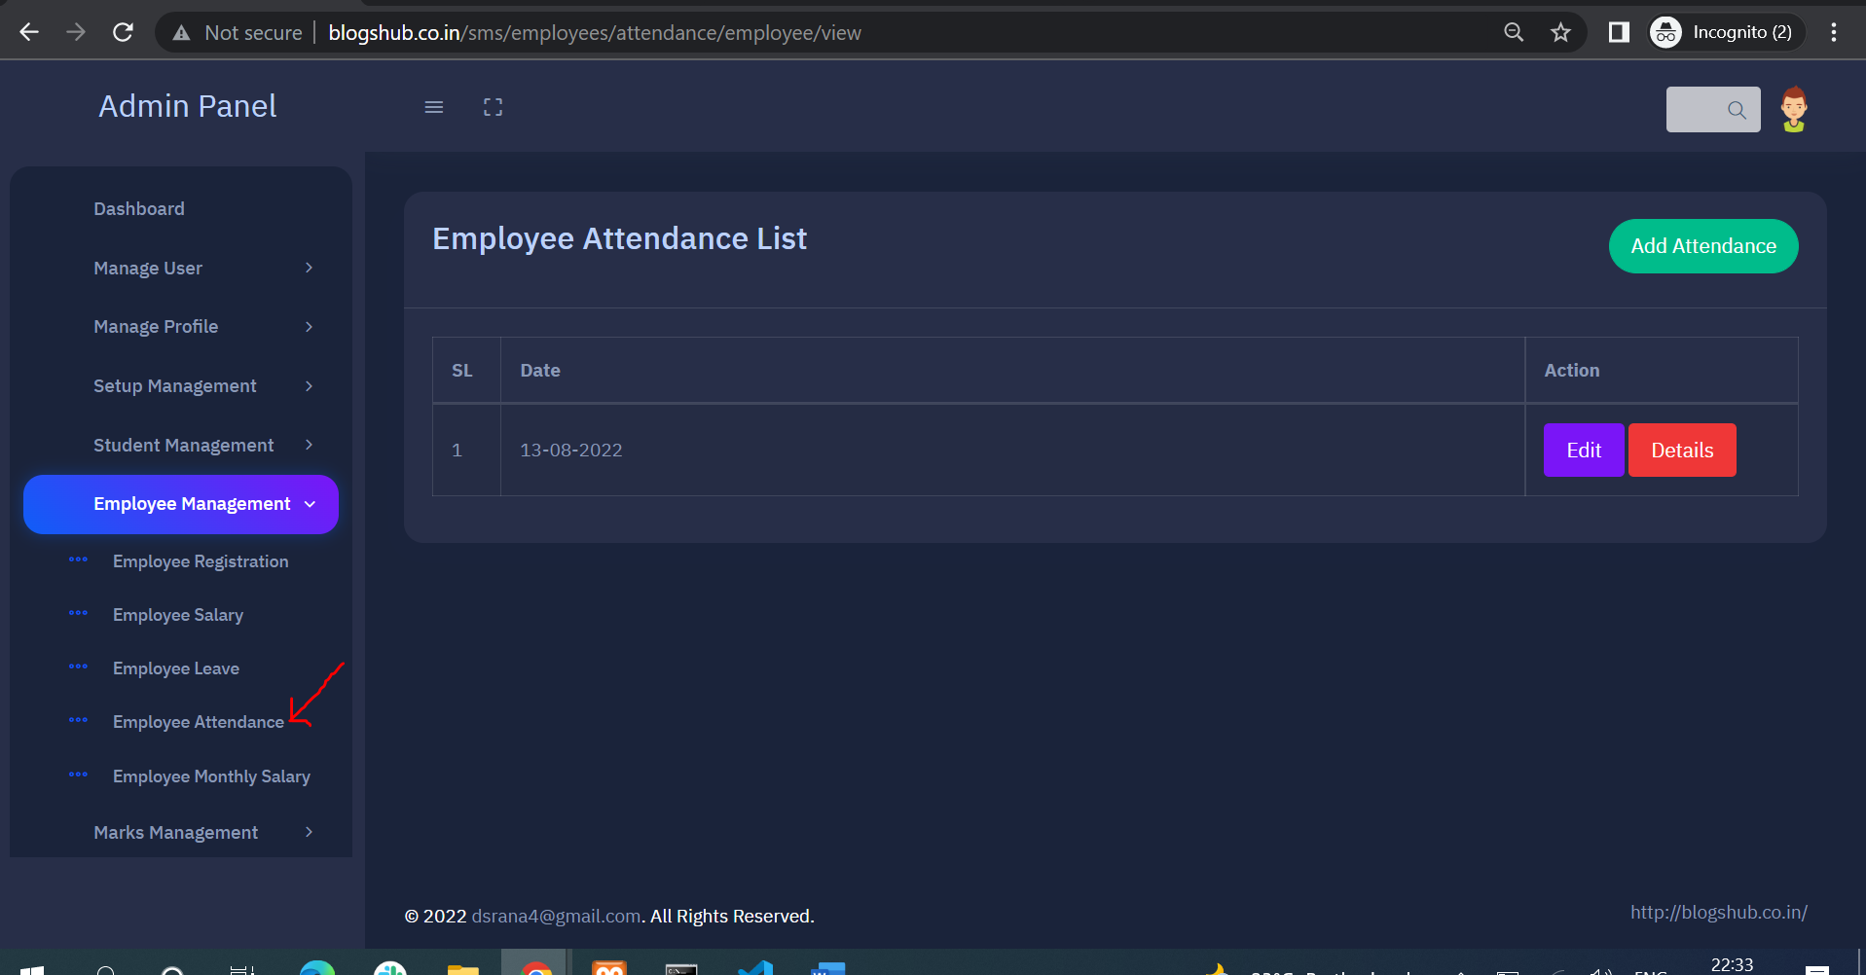

1. **Select date mark attendance and submit the attendance form**

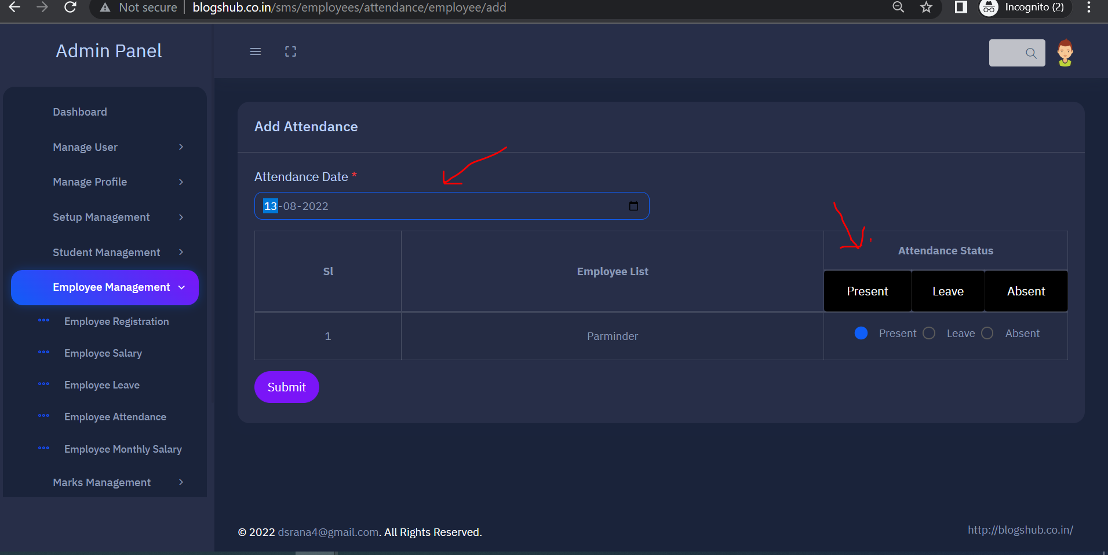

1. **For view and print employee monthly salary click on “Employee Monthly Salary” tab and click on “Pay Slip” button for PDF**

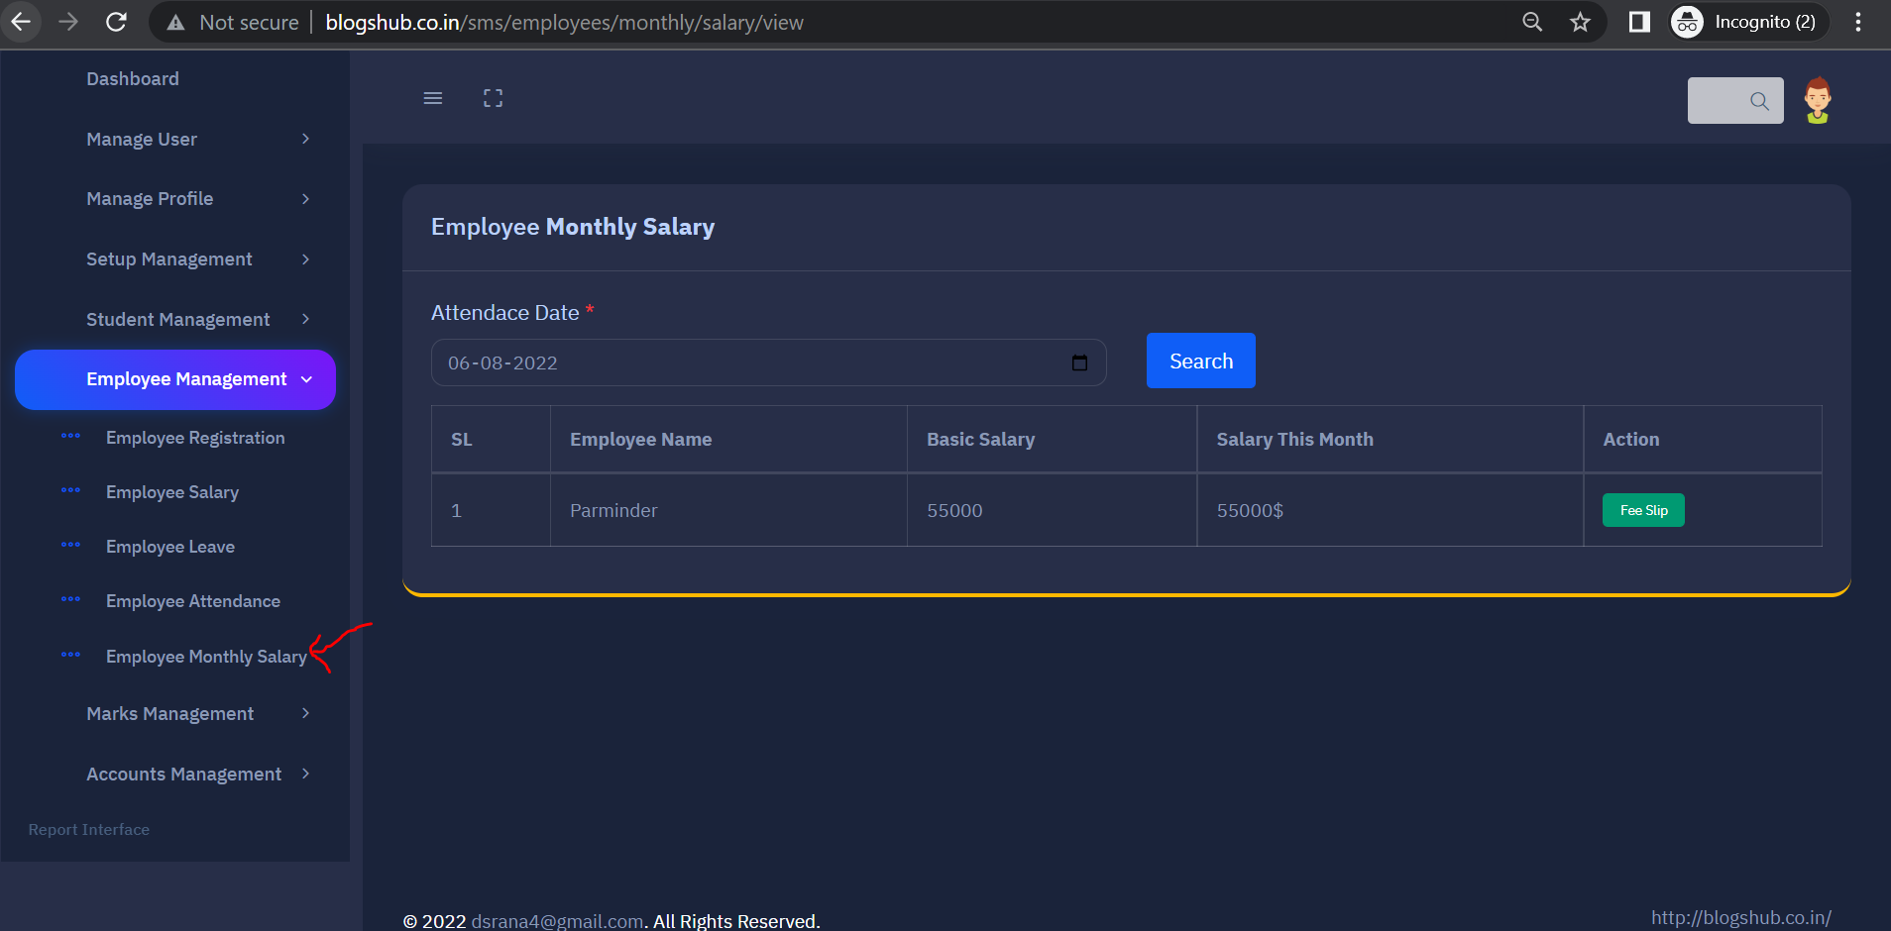

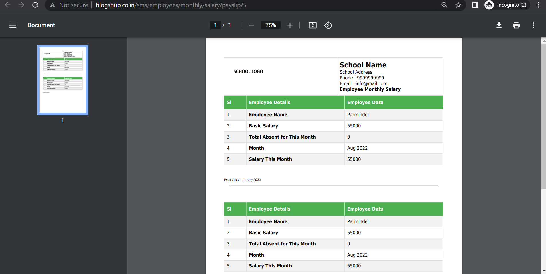

1. **Click on “Marks Management” tab for student subject marks entry**

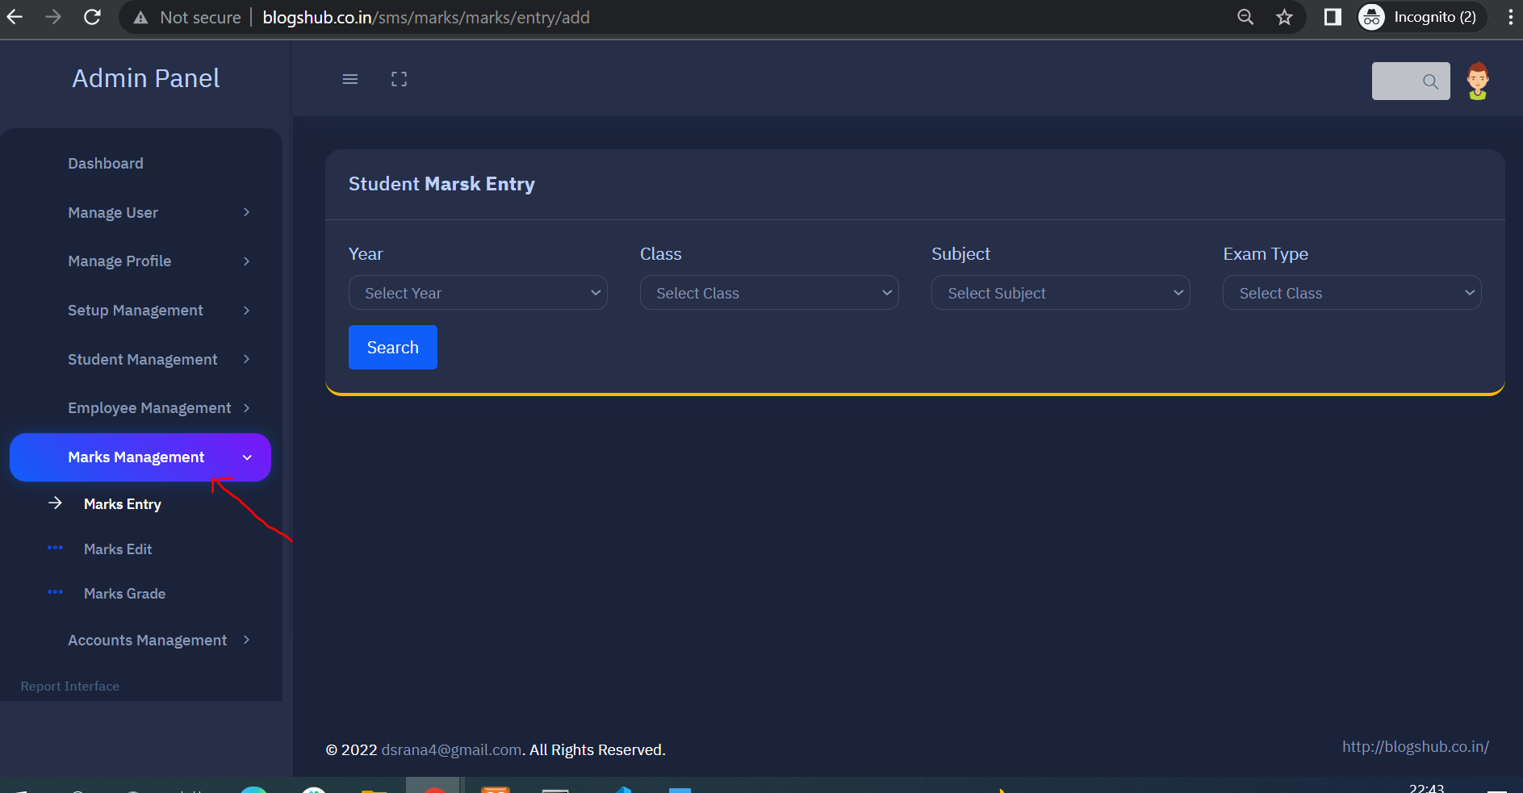

**45). For enter student marks click on “Mark Entry” search by year,class and subject wise**

**Fill students mark and submit form**

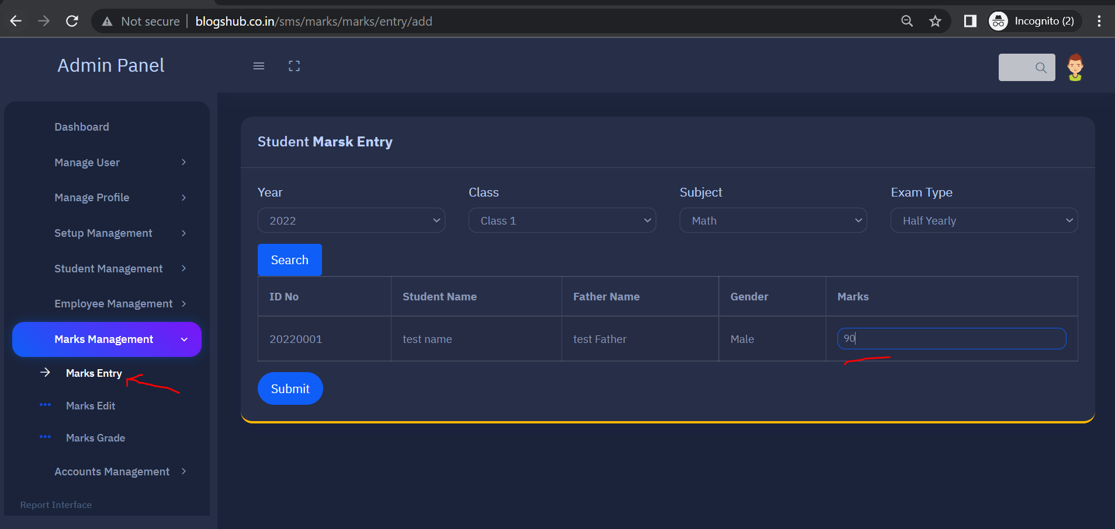

**46). Click on “Mark Edit” tab for edit student marks**

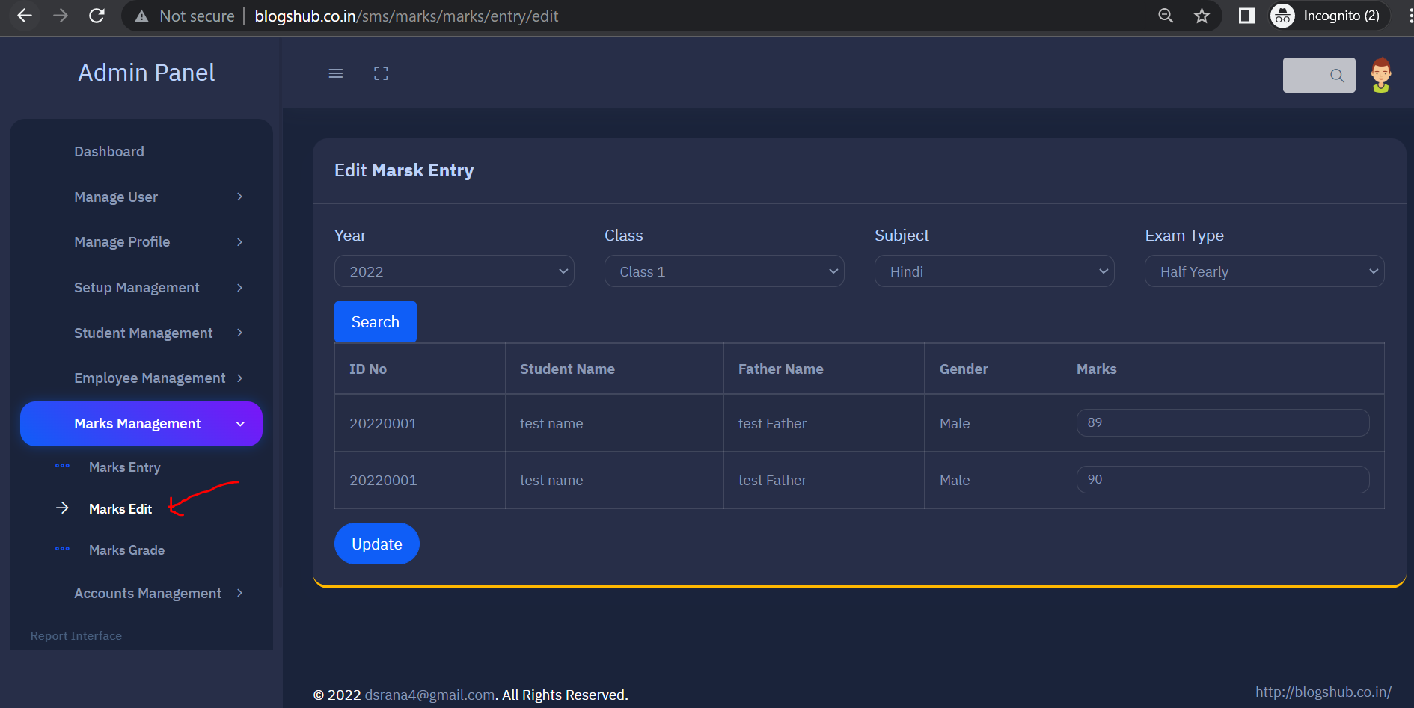

**47) Click on “Accounts Management” tab for manage fee,salary and other cost**

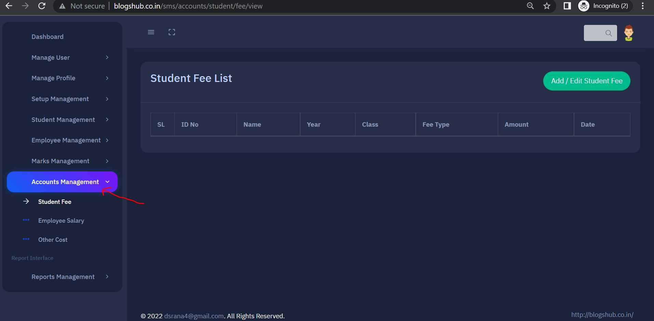

**48) Click on “Student Fee” tab and then click on “Add/Edit Student Fee” button for enter student fee**

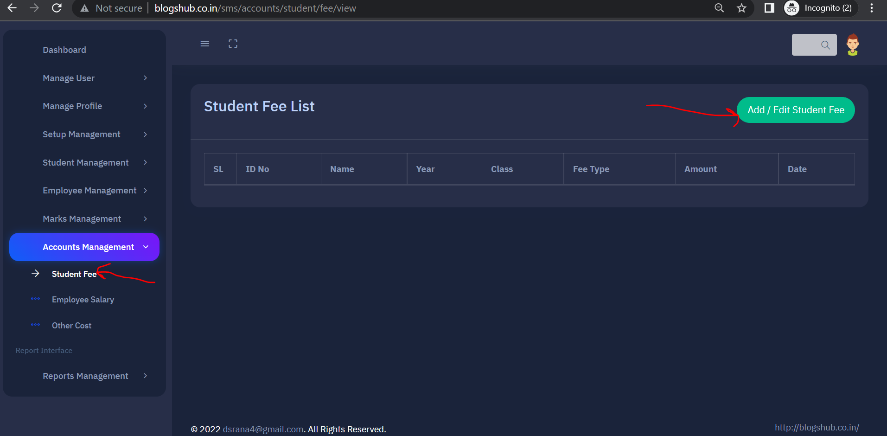

**49) Search Students by year, class and fee category , check in select column and submit the detail**

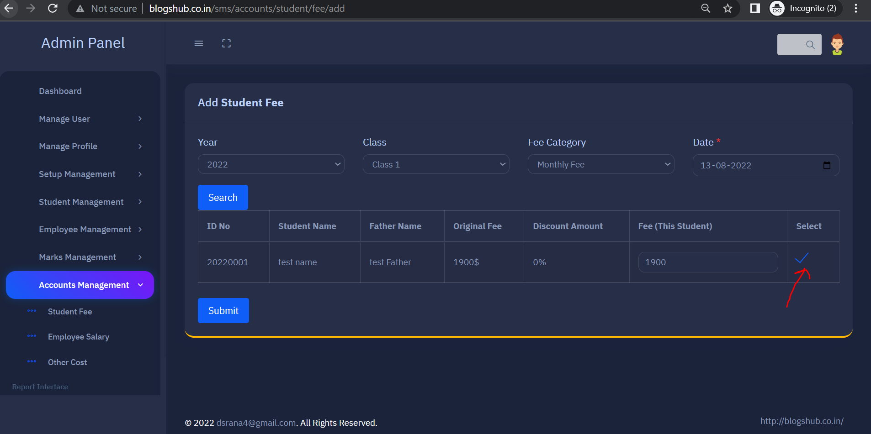

**50) For employee salary entry click on “Employee Salary” tab then click on “Add/Edit Employee” salary button**

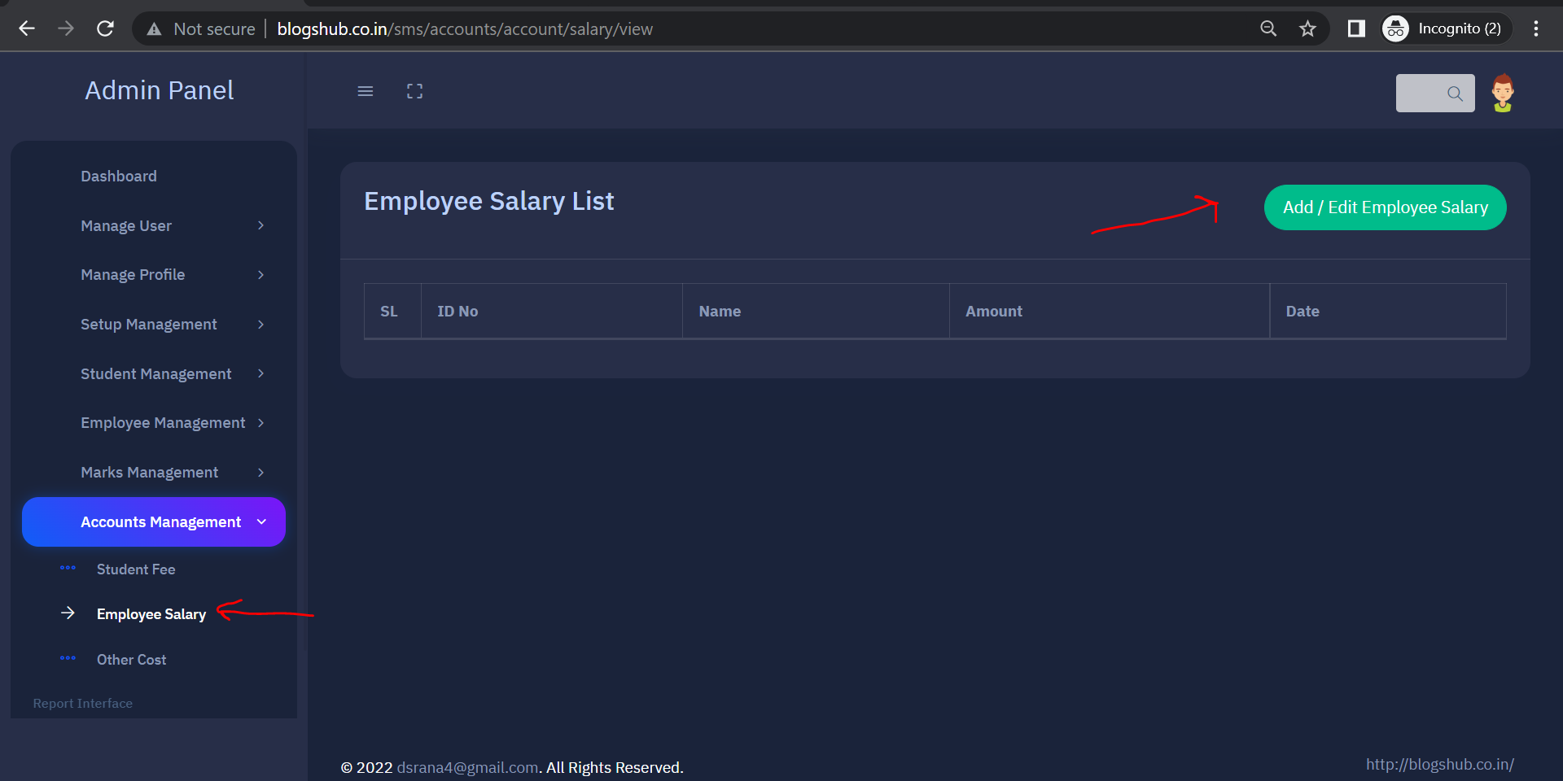

**51) Search by date , select checkbox and click on submit button**

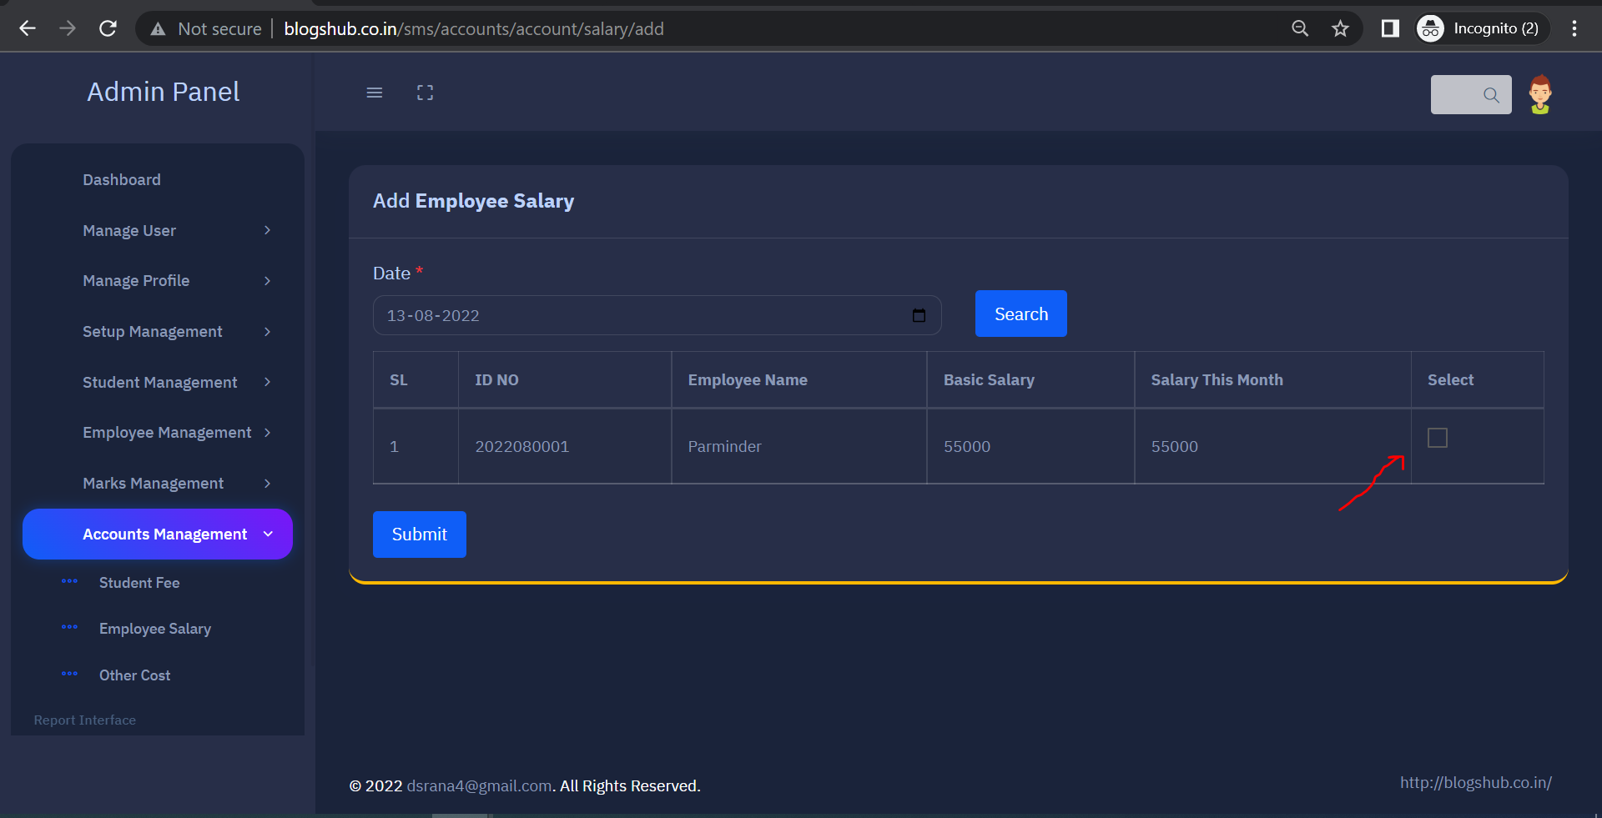

**52) For other expanses click on “Other Cost” tab and click on “Add Other Cost” button**

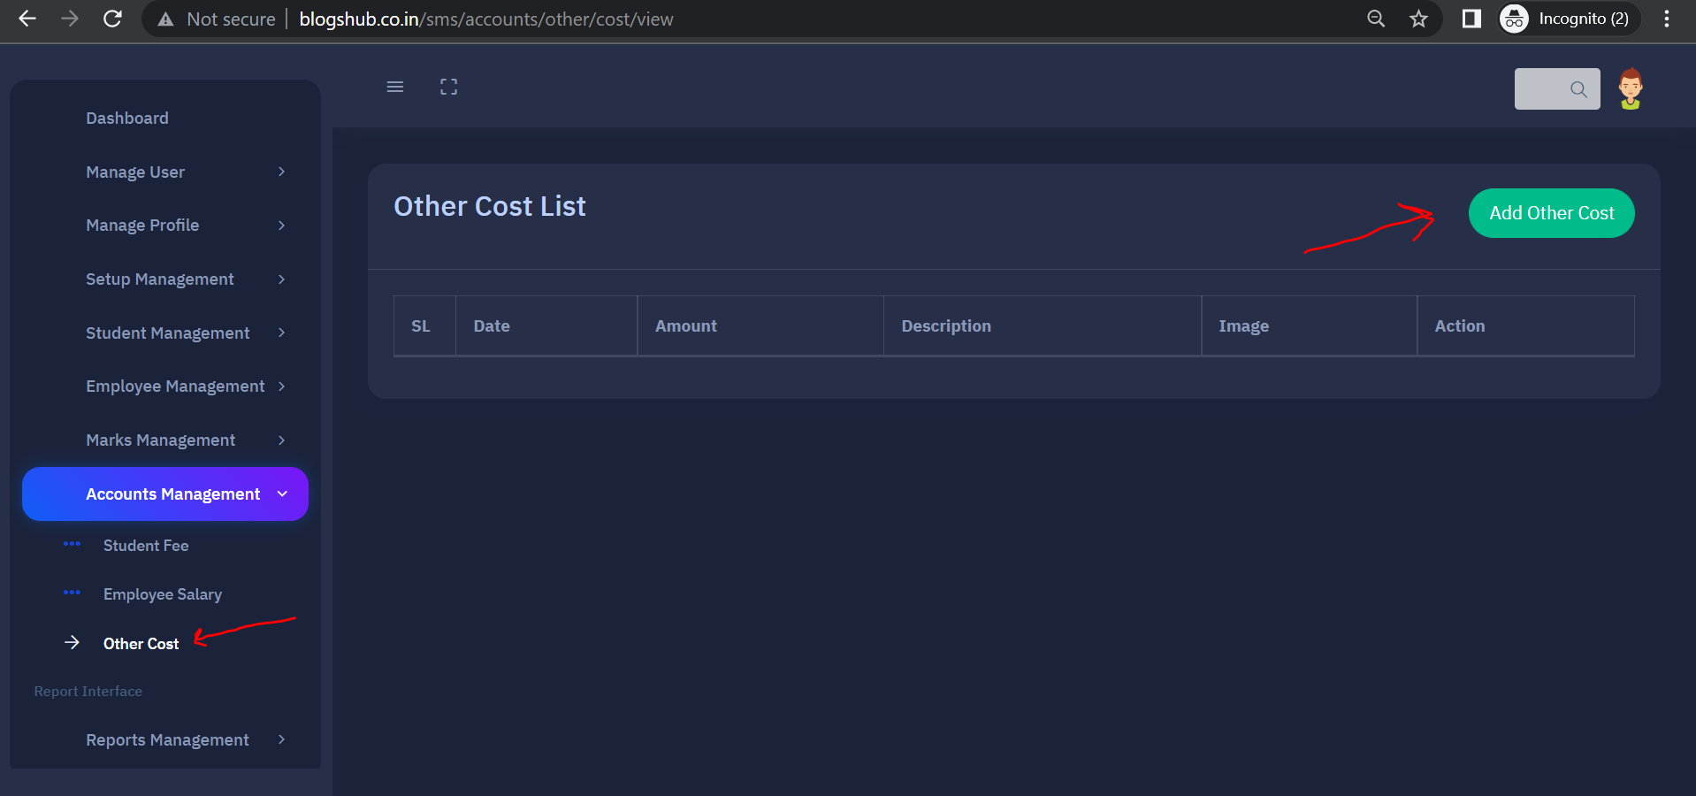

**53) Fill detail and submit other cost form**

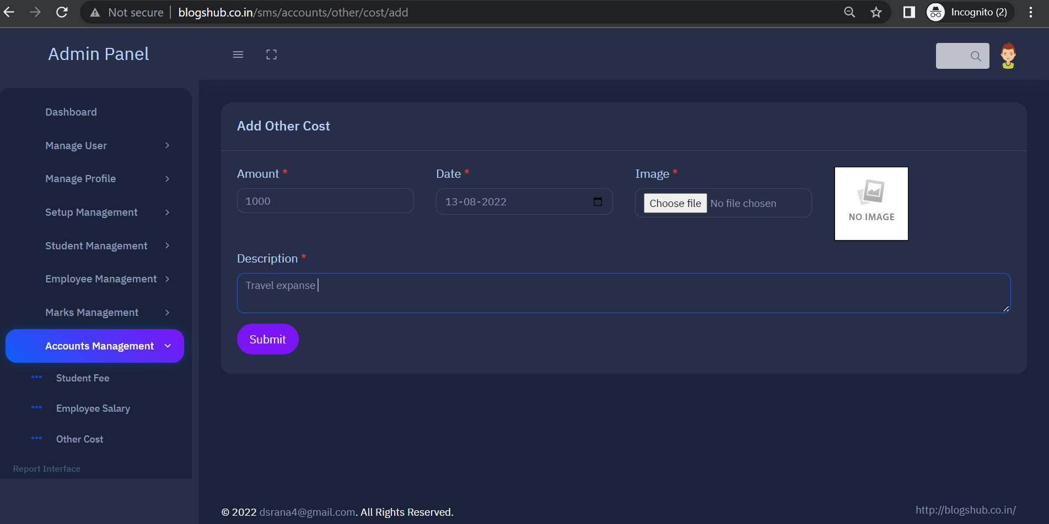

**54) For report section click on “Report Management”**

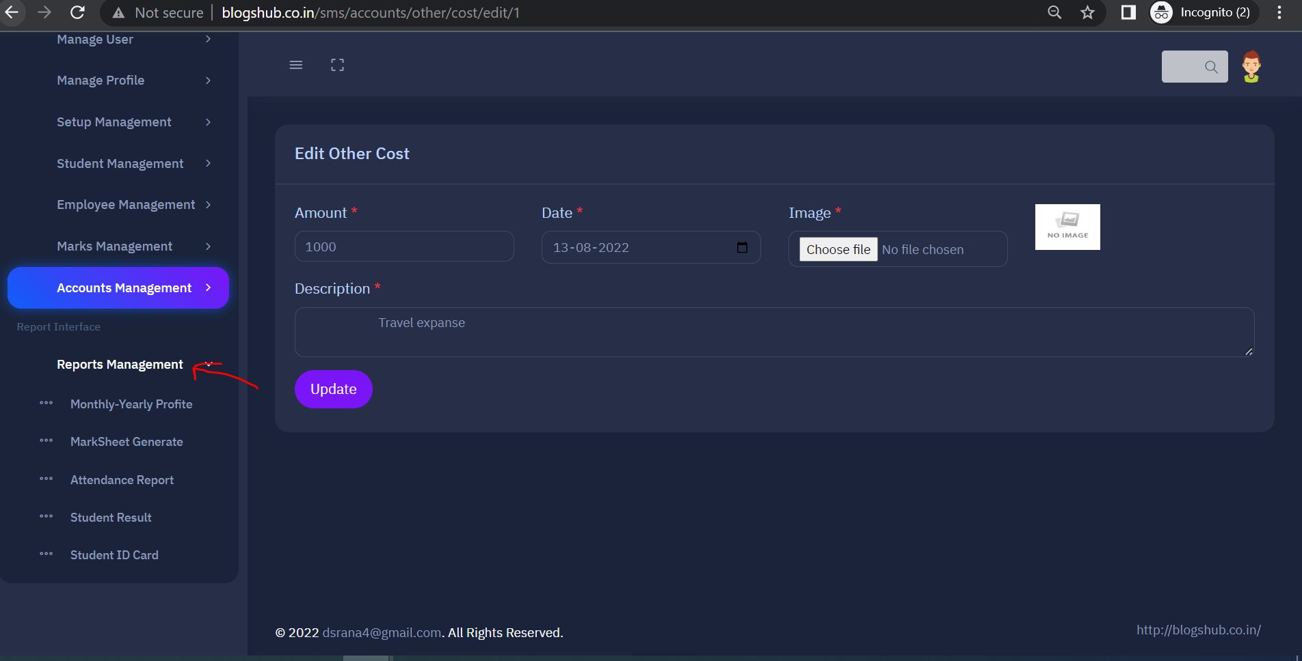

**55) For check Profit report click on “Monthly-Yearly Profit” tab, enter start and end date then click on search button,**

**a) Click on “Pay Slip” button for view Profit and expanse PDF**

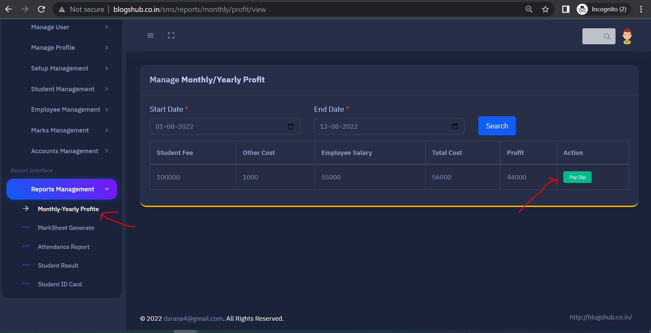

**56) For Generate Marksheet click on “Marksheet Generate” button fill year, class and require fields then click on search button**

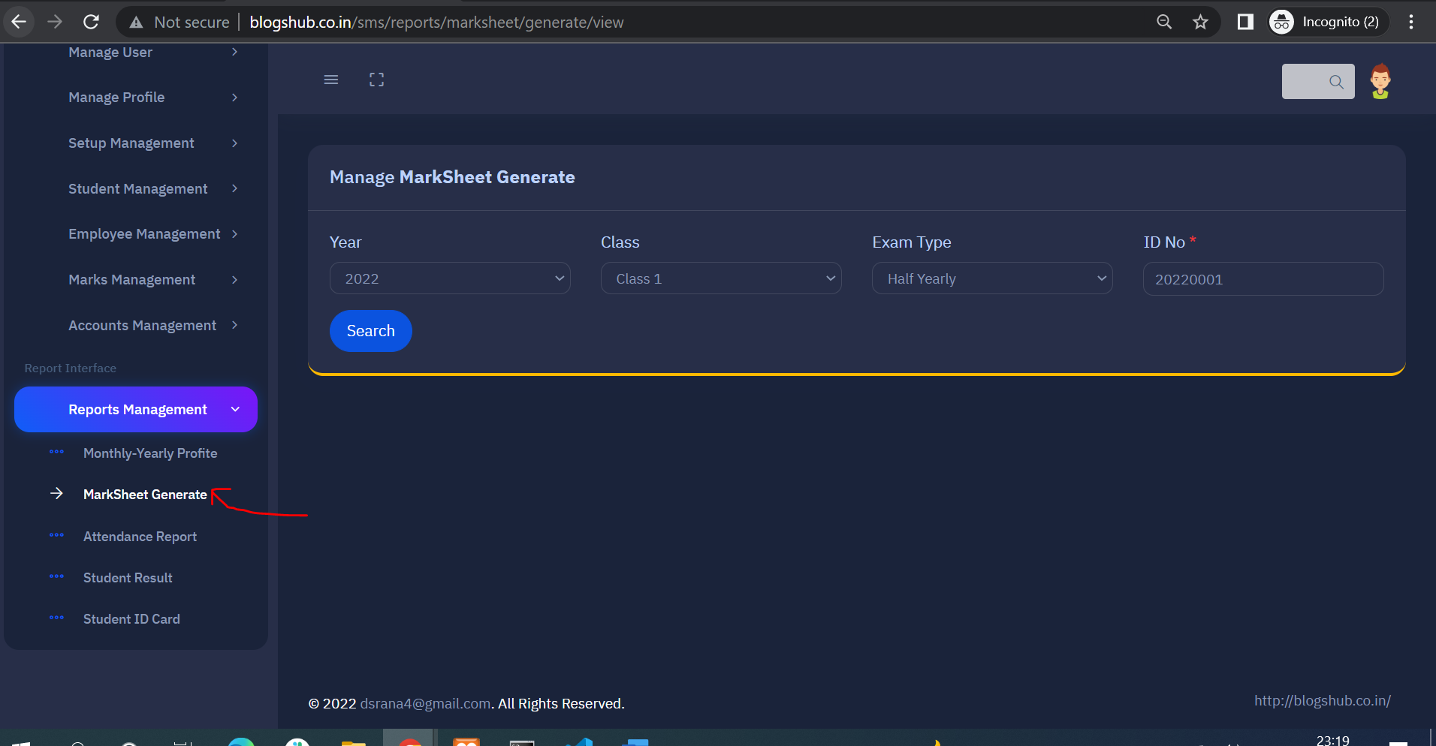

**57) For employee attendance click on “Attendance Report” tab, select Employee name and date then click on search button. PDF will open**

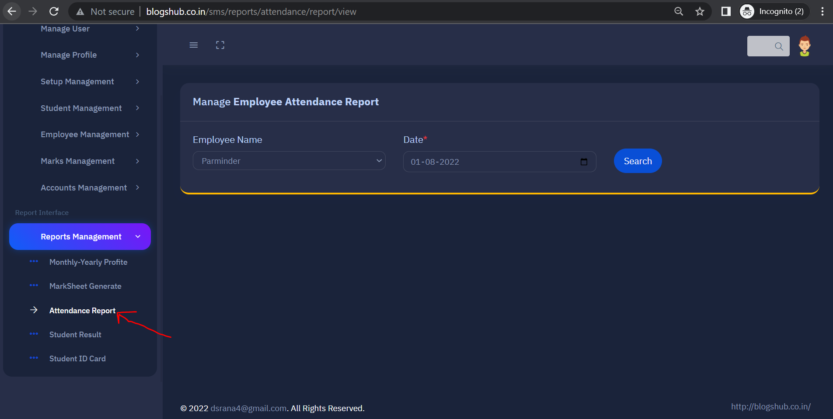

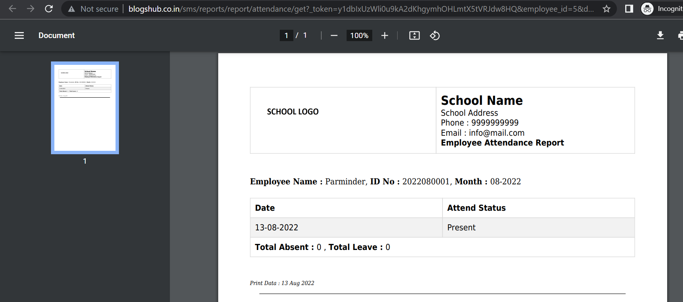

**58) For student ID Card click on “Student ID Card” tab, fill year, class and click on Search button, PDF will generate**

